1.10) Acids and Carbonates

Now you are going to learn another common chemical reaction – Acids and Carbonates.

Acid + Carbonate ➔ Salt + Water + Carbon dioxide

So what is a carbonate? Carbonate has the chemical formula CO₃ and has a valency of -2.

Don’t forget your acids
Hydrochloric acid | HCl
Sulfuric acid | H₂SO₄
Nitric acid | HNO₃
Carbonic acid | H₂CO₃

Examples:

- hydrochloric acid + sodium carbonate ➔ sodium chloride + water + carbon dioxide

HCl + Na₂CO₃ ➔ NaCl + H₂O + CO₂

Can you see how the salt was formed? The sodium came from the carbonate AND the chlorine from the acid

- Nitric acid + ammonium carbonate ➔ ammonium nitrate + water + carbon dioxide

HNO₃ + (NH₄)₂CO₃ ➔ NH₄NO₃ + H₂O + CO₂

You can test for carbon dioxide by bubbling the gas through limewater. The limewater goes from clear to milky if carbon dioxide is present. Another test is that carbon dioxide will extinguish a lit match.

Experiment: Reactions between ACIDS and CARBONATES.

Aim: _____________________________________________________________________

Theory:

Experiment 1 | Experiment 2
Medium Test tube and test tube rack  Stopper and delivery tube  Boiling tube  0.1 M sulfuric acid  zinc carbonate  limewater | Gas jar with candle inside  15 marble chips  1 M hydrochloric acid
Equipment:

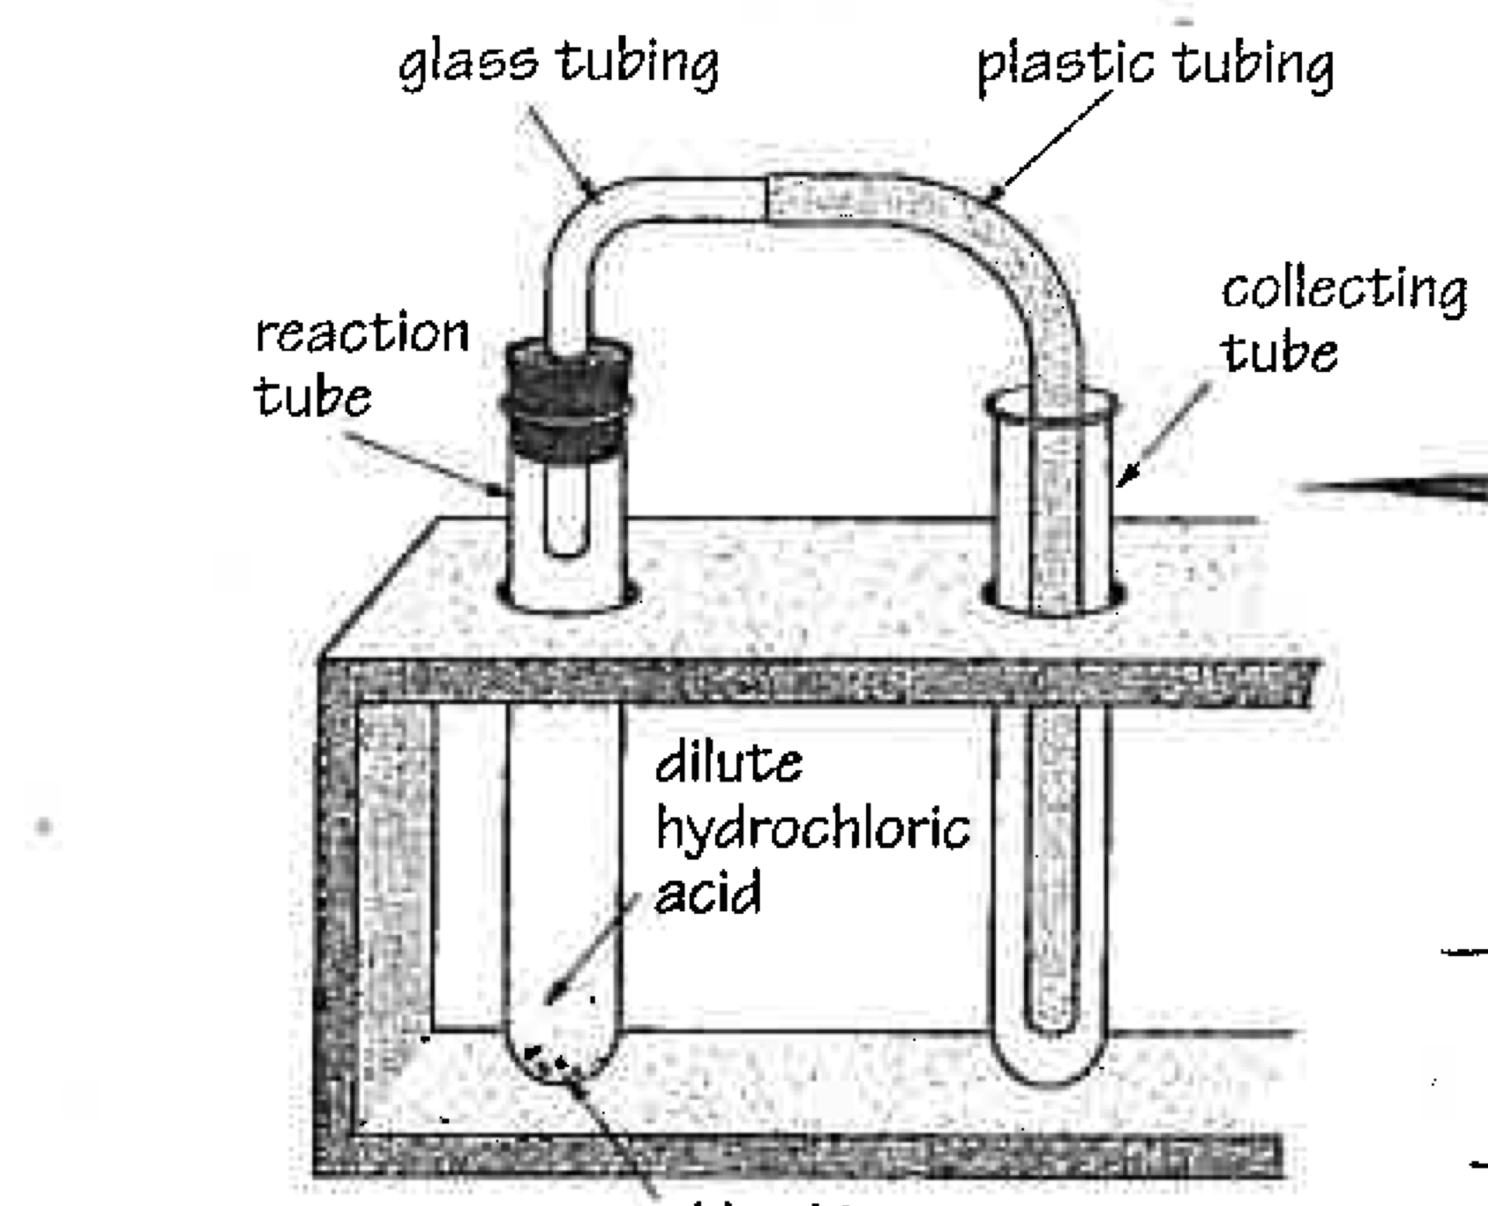
Method:
- In a collecting tube (or boiling tube) place about 6 cm of lime water and place in the test tube rack
- In a medium test tube, place 2 spatulas of zinc carbonate and then add about 3 cm of 0.1 sulfuric acid
- Quickly connect the stopper and delivery tube apparatus as shown in the diagram so that the gas produced goes into the limewater.

- Observe and record results.
- Collect a gas jar with a candle inside it and add marble chips (calcium carbonate) around the base of the candle.
- Light the candle with a long match.
- Then, using a beaker, add 0.1 M hydrochloric acid so that it runs down the side of the gas jar and covers the layer of marble chips. Don’t put out the burning candle
- Observe and record the result.

Discussion:
Explain what you have learned about acid and carbonate reactions as well as the two tests that are used to identify carbon dioxide.

