Constructing Word Equations and unbalanced Chemical Equations

Use the following steps to write unbalanced chemical equations:

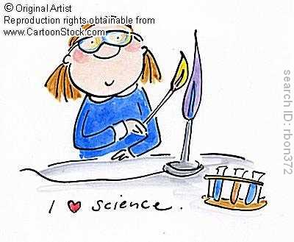
- Write the word equation
- Directly underneath the word equation, write the unbalanced formula equation
- Add subscripts – (s), (l), (g) or (aq)
- Extension: Balance the equation as shown in class. Remember to start with the metals, then non-metals, then oxygen and finally hydrogen.

Remember:

Non-metal gases are usually diatomic
- If sulphuric acid is poured onto solid sodium carbonate, bubbles of carbon dioxide are produced as well as water and the soluble salt sodium sulfate.

- Magnesium burns easily in oxygen, producing solid magnesium oxide

- Iron (II) metal reacts with chlorine gas to produce solid iron chloride

- When solutions of lead nitrate and sodium iodide are mixed, a precipitate of yellow lead iodide is formed as well as sodium nitrate in solution.

- When dilute sodium sulfate solution is added to dilute barium nitrate solution, barium sulfate precipitates, leaving sodium nitrate solution

- Dilute hydrochloric acid is added to solid magnesium hydroxide, producing water and the soluble salt magnesium chloride.

- When methane (CH₄) is burned in air, carbon dioxide and water are formed

- Dilute sodium hydroxide is added to dilute sulphuric acid, producing water and the soluble salt sodium sulfate

- When aluminium reacts with chlorine gas, solid aluminium chloride is produced

- During photosynthesis, the Sun’s energy, carbon dioxide and water are used by green plants to produce glucose and oxygen.

- When copper is added to nitric acid, copper nitrate, gaseous nitrogen monoxide and water is formed.

