What is Natural Selection?

Evolution is the gradual development of different species from a common ancestor. Most scientists now agree that evolution occurs very slowly by a process known as Natural Selection. Charles Darwin is responsible for developing the theory of Evolution via Natural Selection.

So what is it? Complete the four activities below to find out more.

Activity 1: watch the video at the link below and answer the questions that follow.

http://education-portal.com/academy/lesson/genetic-variability-and-random-mutation.html#lesson

- What is an adaptation?
- How is a long neck a useful adaptation for giraffes?
- Explain how the giraffe came to have a long neck.
- What happened to giraffes with shorter necks?
- Why is reproduction an important part of evolution and natural selection?
- Define the term natural selection.

Activity 2: watch the video at the link below and answer the questions that follow.

http://www.youtube.com/watch?v=0SCjhI86grU

- What does “descent with modification” mean?
- What does “common descent” mean?
- Why is common descent described as a “conclusion”?
- Describe some of the observations Darwin used to help support the theory of common decent and descent with modification.
- How do tortoises on the Galapagos Islands differ? How is each species is suited to it’s environment?
- What is selective breeding? Given an example to support your answer.
- How is nature capable of “selection”?
- What is “natural selection”?

Activity 3: study the image below and then answer the question that follows.

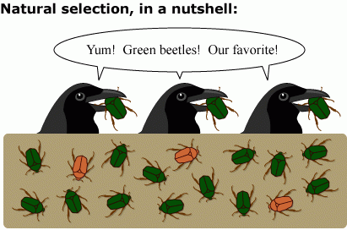

- What message do you think this image is trying to convey? Explain your answer, referring to specific examples from the image.

