2.12) Build Your Own Loudspeaker for your Computer!

Firstly watch the youtube clip - http://youtu.be/EIbzQ_8-aaM

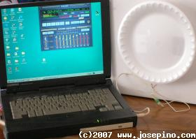

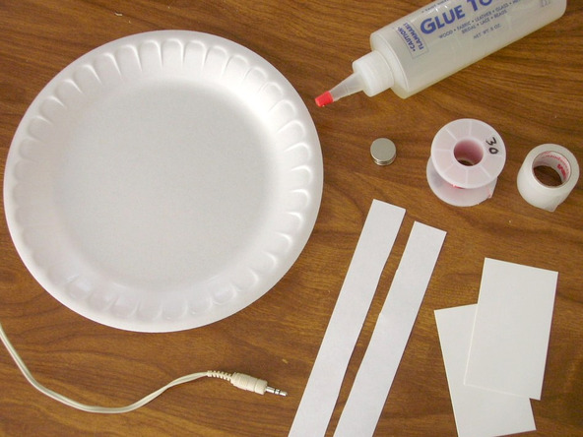
Equipment List

- Foam plate.
- Two strips of paper.
- Two business cards.
- Copper wire, AWG 32 (enameled)
- Tape.
- Glue. (Hot glue works great)
- Neodymium magnet.
- Audio plug.

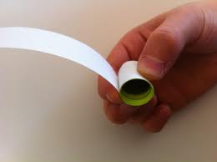
- First, roll one strip of paper over the magnet. Use tape. Do not tape the paper to the magnet.

- Roll the second paper strip over the first one. Do not tape the paper with the first roll.

- Remove the magnet after the paper cylinder is ready

- Glue the paper cylinder to the plate; try to glue it exactly at the center of the plate.

- Start making the coil – you can put the magnet back inside so you don't crush the paper cylinder.

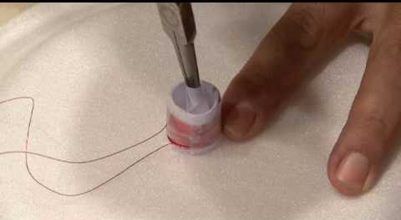
- Make about 50 turns of wire (AWG 32). If you don't have copper wire AWG 32, then use AWG 30 but be sure the coil has at least 7 ohms. After you finish the coil, remove the magnet and the inner paper cylinder. Discard the inner paper cylinder and try not to damage the second one. The inner cylinder is only used to create a gap between the magnet and the coil.

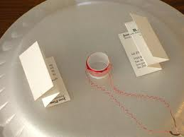
- Fold the business cards as the picture shows.

- If the magnet is not high, try to make small three tight folds only, so the coil stays just above the magnet.

- Glue the cards to the foam plate. Try to make both business cards parallel. Check that the business cards are higher than the coil.

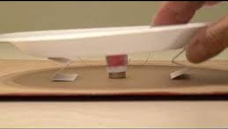

- Now, put some glue on the magnet and each business card and stick to the base. The "base" can be a solid cardboard or wood. Anything flat and rigid works fine. I did use a cardboard. Using wood, the sound is better as wood vibrates less than cardboard.

- Check the wires, keep the wires away from the business cards or it may cause some noise and/or a rattle noise, so try to keep both wires separated.

- Remove about 1 cm of the coating from the copper wire tips.

- Using a Mono plug, just connect one end of the wire to the center connector and the other end to the side connector of the plug.

- Plug into the microphone jack of your computer and you are ready to listen to music

NOTE:

If you are using a STEREO plug, just connect one end of the wire to the center of the plug and the other end to ANY of the side contact from the plug. Don't forget to remove the coating from the copper wire (Yes, I told you, it should be enameled copper wire. Just bare copper wire is not going to work.

