Biotic and Abiotic Factors (taken from Core Science 5 Jacaranda)

The parts of an ecosystem that are non-living are called the abiotic environment. The parts that are living are called the biotic environment.

- Complete the table below by classifying the named component as biotic or abiotic.

Component | Biotic or abiotic? | Component | Biotic or abiotic?
Water salinity |  | Competitors for mating
Wind speed and direction |  | Producers
Competitors for food |  | Humidity
Predators |  | Bacteria
Light penetration |  | Air temperature

2. The following photo shows a clownfish sheltering amongst the poisonous tentacles of a sea anemone. The sea anemone does not harm the clownfish as it searches for food.

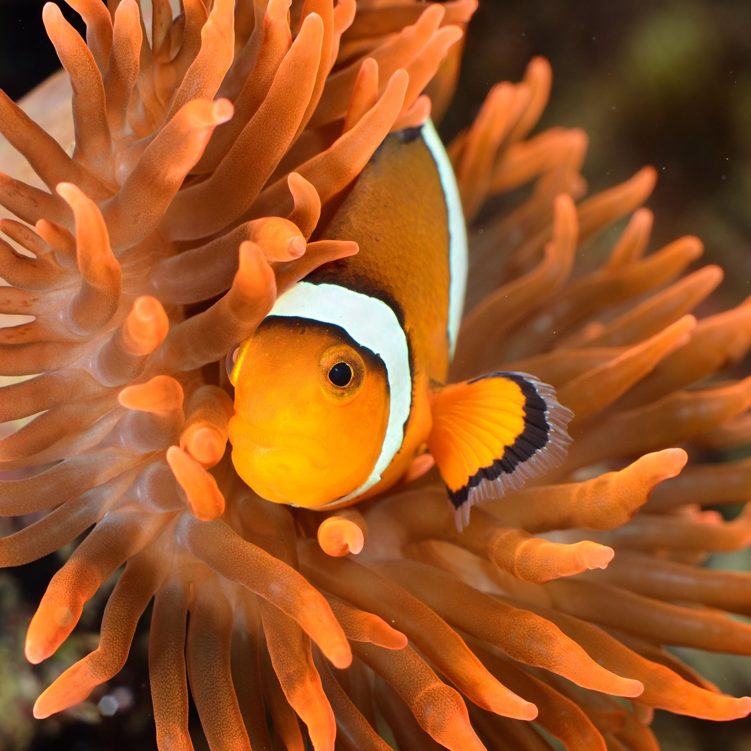  © Aleksey Stemmer/  Shutterstock.com | (a) Identify two abiotic components of this ecosystem.  (b) Identify two biotic components of this ecosystem.  (c) How does the association of the clownfish with the anemone benefit the fish?

3) The illustration below shows a boy on a field trip in the Australian bush.
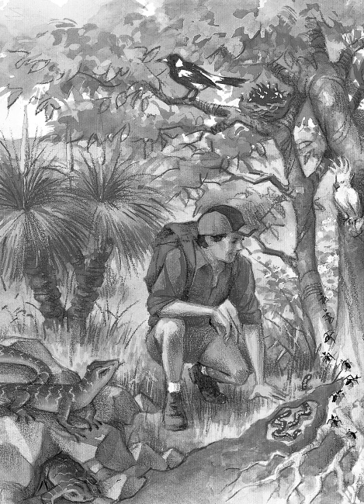 | (a)Explain the importance of the trees and grass to this ecosystem.  (b)Earthworms are shown in the soil under the tree. Explain the importance of these worms to the ecosystem.  (c) The student decides to measure an abiotic factor in this area. Identify an abiotic factor he could measure and describe how he will perform this task.

