Food Webs and Pyramids (Taken from Core Science 5 Jacaranda)

1. Examine the two graphics below and answer the questions that follow.

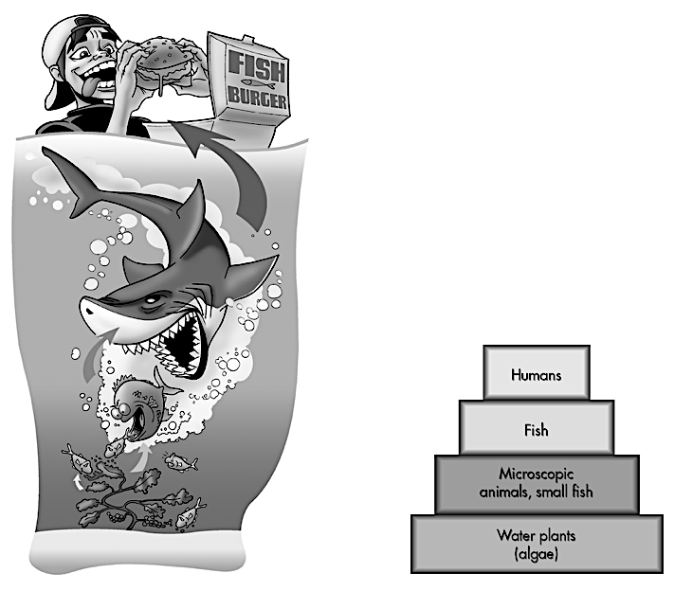

- Identify the producers in the food chain.
- In this food chain what type of consumer are the humans?
- Explain why the food chain is represented as a pyramid.
- What is the ultimate source of energy for this food chain?

2. Examine the food web below and answer the questions that follow.
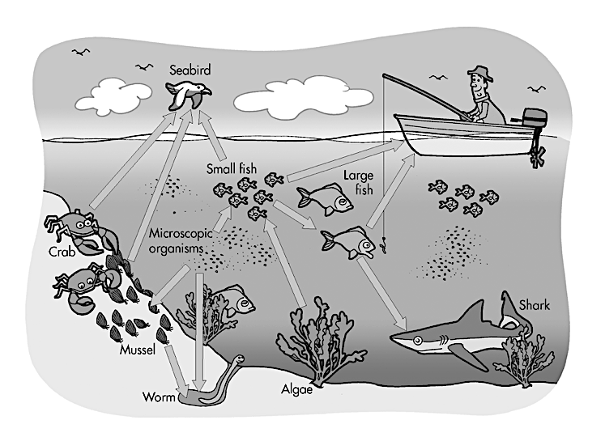

- What type of living things could make up the ‘microscopic organisms’?
- Write a food chain based on this food web that includes a third order consumer.
- If a disease kills all the algae in this area what effect will this have on the food web?

