2.3) Fertilisation

WINKS - describe the process of fertilisation

Human fertilisation is the union of a human egg and sperm. This occurs in the fallopian tube.

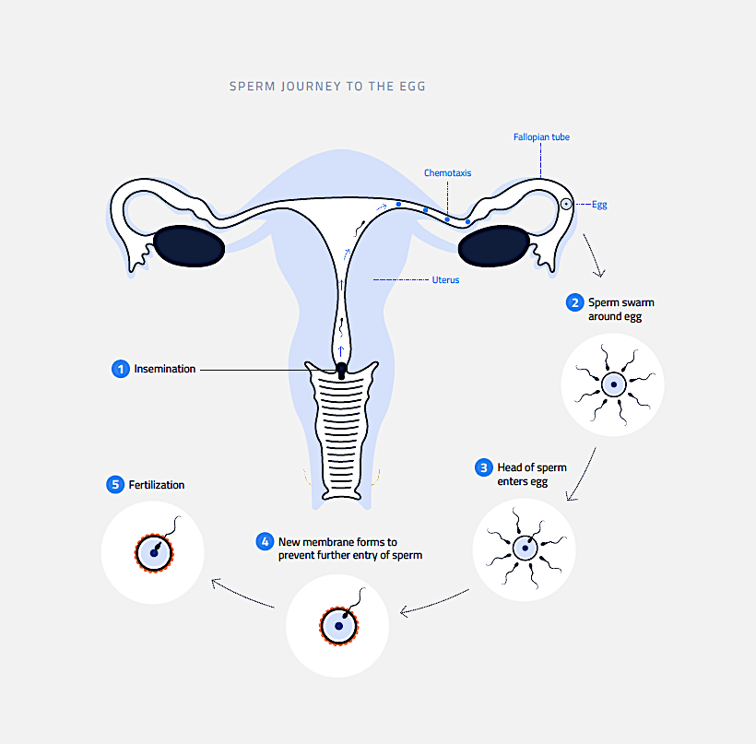

Even though several sperm reach the egg, only one will break through the cell’s membrane and fertilise the egg. This is represented as day 0 in the diagram below.
