Population fluctuations

In some instances it is important to study fluctuations in populations so we can get an idea of normal patterns and identify unusual rises and falls in populations. Fluctuations can also give us information about environmental factors that affect the size of populations.

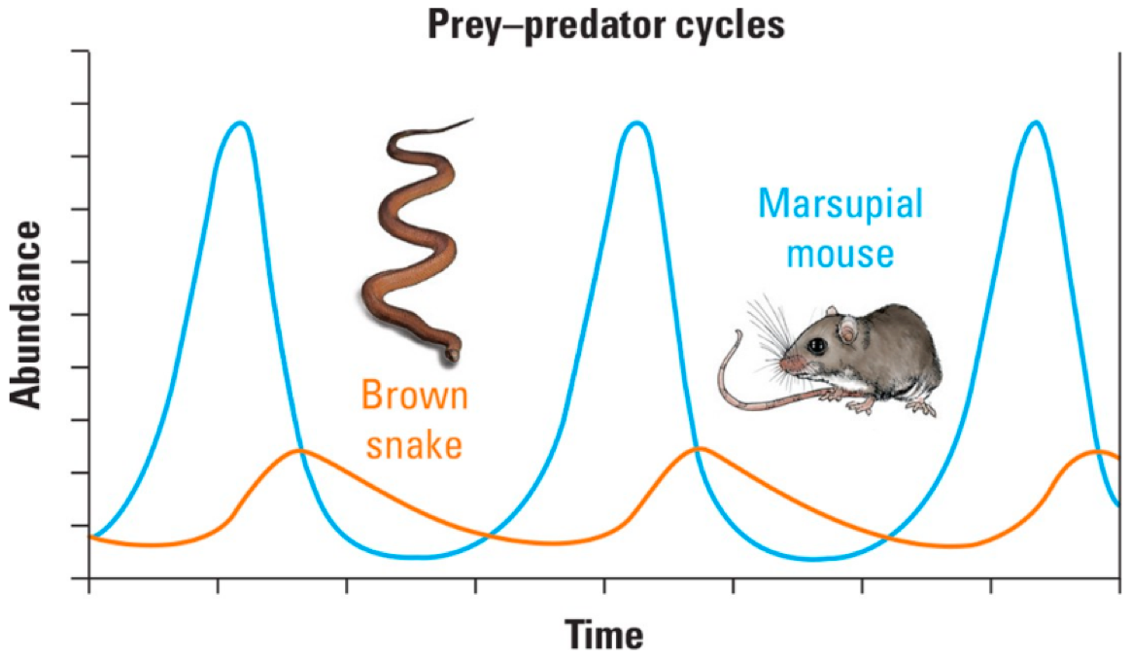

- Study the graph above.
- Imagine that a species that feeds on marsupial mice was introduced to the area. Describe the impact on the population of marsupial mice and brown snakes.
.....................................................................................................................................................
.....................................................................................................................................................
.....................................................................................................................................................
- Explain why there is time delay between the rises and falls in the prey and predator populations.
.....................................................................................................................................................
.....................................................................................................................................................
.....................................................................................................................................................
.....................................................................................................................................................
.....................................................................................................................................................
- Explain why the maximum number of brown snakes is significantly less than the maximum number of marsupial mice. Do you think this would always be the case regardless of the predator and prey?
.....................................................................................................................................................
.....................................................................................................................................................
.....................................................................................................................................................
.....................................................................................................................................................
.....................................................................................................................................................

- The table below shows how the number of echidnas and dingos changed over time in a particular area of bushland.

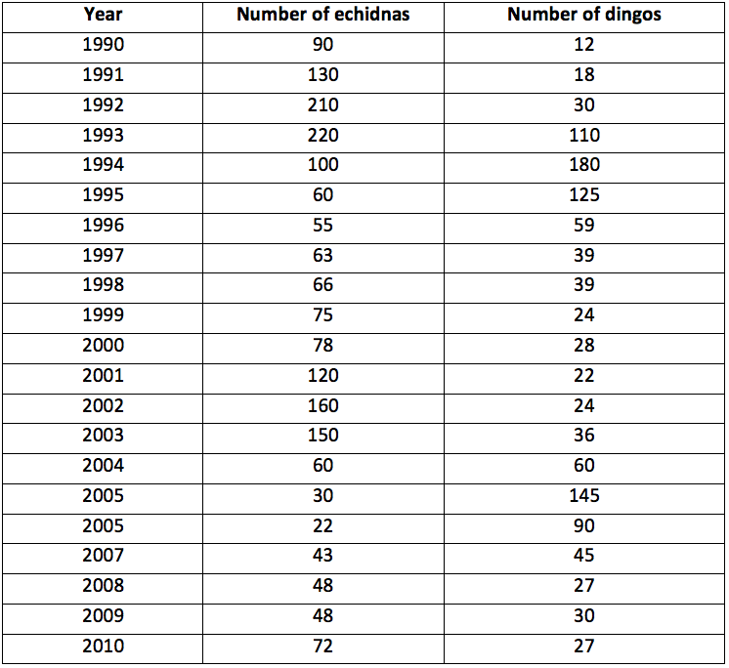

- Construct a graph showing how the number of echidnas and dingos changed between 1990 and 2010
- Identify the predator and prey. How can you tell from the graph?
.....................................................................................................................................................
.....................................................................................................................................................
- Outline what would happen to the number of echidnas if hunting caused dingo numbers to decrease dramatically.
.....................................................................................................................................................
.....................................................................................................................................................
- Echidnas feed on ants. If dingo numbers fell, outline the impact on the ant population. Describe the long-term impact on the echidna population.
.....................................................................................................................................................
.....................................................................................................................................................
.....................................................................................................................................................

