Practical Activity) Sound Uncovered

Sound is caused by a vibration, such as a flag flapping in the wind, a plucked guitar string, the human vocal chords or a drum skin. Air molecules around the object are moved causing a sound wave to travel away from the vibrating object. Sound can travel within solids, liquids or gases but not through a vacuum.
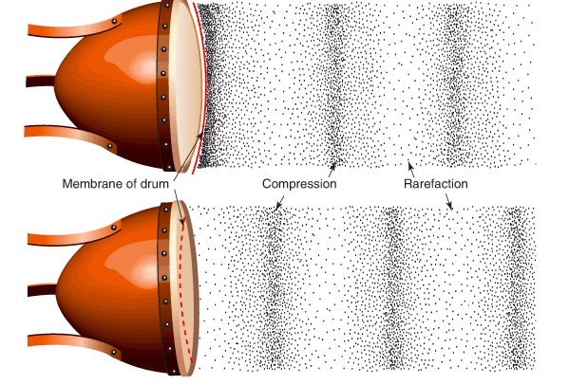

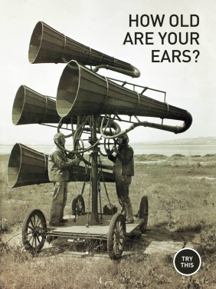
Prac 1: Exploring Sound

This activity requires you to download the free iPad application ‘Sound Uncovered’, by Exploratorium. You will complete several activities to get you to think about what sound is and how we detect and use it. The activities that relate to the questions on this worksheet are ‘Eyes and Ears’, ‘How old are your ears’ and ‘Silent day, Noisy night’. You are encouraged to investigate the others too! Write your answers in your workbook

Eyes vs Ears
1. Why do you think we hear the same word differently with our eyes open and shut?

How old are your ears?
1. Could you hear all of the sounds? Why?

2. What do you think frequency refers to? What do higher frequencies sound like?

Silent day, Noisy night
1. How does temperature affect sound?

2. What happens sound on a hot, sunny day? Draw a diagram to support your answer.

3. What happens to noise on a cool night? Draw a diagram to support your answer.

Prac 2: Frequency, Pitch, Amplitude and Loudness

Using an oscilloscope (we will use Soundbeam, an iPad app), observe what happens to the representative sound wave as the frequency of a sound increases and decreases. Use the tuning forks available to create sounds. To conduct these tasks, make sure the spectrum button on the app is off

- We can represent sound waves as transverse waves. What do you think a crest and a trough would represent? Hint use the diagram of a sound wave from a drum.

- Using the oscilloscope app on your ipad and a tuning fork, explore what happens to a sound wave that is the same note but different loudness level.

- Draw transverse waves to represent a) a loud sound and b) a soft sound.

- When the loudness of a sound changes, what property of the wave changes?

- Now use the oscilloscope and different tuning forks to explore what happens to a sound wave that is a different note but same frequency

- Draw transverse waves to represent: a) high pitch (or note) and b) low pitch (or note).

- Identify what happens to a sound’s wavelength when frequency increases.

