3.7) How have Aboriginal and Torres Strait Islander people managed Australian Ecosystems?
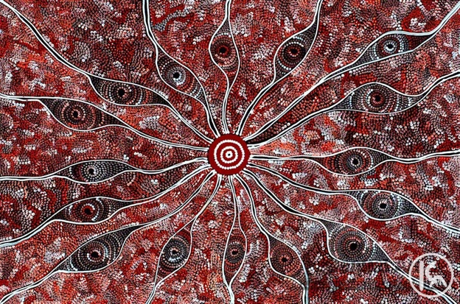

Fire Dreaming by Maureen Hudson Nampijinpa, Central Australia

WINK
9. Assess ways that Aboriginal and Torres Strait Islander peoples’ cultural practices and knowledge of the environment contribute to the conservation and management of sustainable ecosystems

Question 1) First understand the WINK point, hence define the terms ‘ conservation’ and ‘sustainable ecosystem’

For over 50,000 years, Australia’s Indigenous community cared for country by using land management that worked with the environment. Their spiritual connection with the Earth was central to all their land practices. Using traditional burning, fishing traps, and sowing and storing plants, they were able to create a system that was cared and nourished the landscape and supplied them with the food they needed. When Europeans arrived, they brought farming practices suited to an environment very different to Australia, that in the long-term caused erosion and salinity. Now there is a shift occurring towards the Indigenous methods as they develop more sustainable ecosystems.

Aboriginal people understood Australia’s low crop productivity. The soil is relatively infertile and the rainfall generally very low hence these conditions do not support intensive agriculture without the help of synthetic fertilisers. For these reasons, Aboriginal people remained nomadic (moving about almost continuously), rather than settling to intensively cultivate one area of land. They were taught not to catch more food than they needed and each tribe had a totem animal that was not eaten (thus protected). There were universal rules in harvesting food that were generally respected such as only one tree fern fronds can be eaten from each plant. They survived and settled expansive areas of Australia using the following land management techniques.
A) Firestick Farming: An Ancient Practice
Firestick farming is an ancient Aboriginal land-management practice which involves using a mosaic (patchwork squares) of low-intensity fires. This technique is still used in the Top End to:
- Reduce high intensity (hot), late season, long burning catastrophic wildfires which kill wildlife, decrease biodiversity, and contribute to greenhouse gases.
- Increase early season, low-intensity (cool) fires to keep undergrowth low, reduce fuel loads and which burnt out quickly, putting fewer emissions into the atmosphere.
- Create MOSAICS of ecosystems at different stages of growth to support high biodiversity with unburnt sections acting as game reserves.
- Herd animals into an area for hunting, clearing walking trails of debris and snakes, discouraging and reducing insects and encouraging large herbivores into recently sprouted grasses after fire.
Over time, naturally changing climatic conditions, along with Aboriginal use of firestick farming, have transformed Australia’s ecosystems by:
- Encouraging fire-resistant and fire-dependent plants. E.g. Eucalypts (epicormic growth), Banksia (seeds need smoke to open).
- Changing the landscape from forested areas to grassland.
- Potentially contributing to the extinction of Australia’s mega fauna.
- Decreasing moist rainforest areas (some fragments remain in isolated, remote, high rainfall areas).
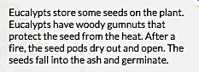
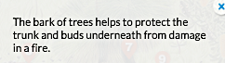
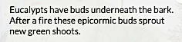
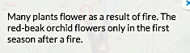

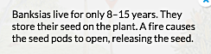

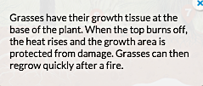

Question: Watch this youtube video “Three things I know about fire management” https://www.youtube.com/watch?v=KZ_En7x8tzU to develop your understanding.

b) Semi Nomadic
Aboriginal people lived in small family groups and were semi-nomadic, with each family group living in a defined territory, systematically moving across a defined area following seasonal changes.

Question: Explain how a semi-nomadic lifestyle would support the management of a sustainable ecosystem.

C) Totem
Each tribe had a totem animal that was not eaten and hence protected.
Question: Explain how this would support the management of a sustainable ecosystem.

Additional Resources

- Core Science 5 Section 13.8 Inspired by Traditional Owners

- Watch these videos
- Firestick Farming - https://www.youtube.com/watch?v=mwUyaeWxJhA
- Fire Management - http://splash.abc.net.au/media/-/m/29925/management-of-the-northern-savanna (2 minutes)
- The Last of the Nomads - http://aso.gov.au/titles/documentaries/the-last-of-the-nomads/clip2/ (3 minutes)
- Fire Power - https://www.youtube.com/watch?v=pEFbHxMUEYk (18 minutes)

- There are also several interesting articles
- Traditional Aboriginal Burning -https://www.dpaw.wa.gov.au/management/fire/fire-and-the-environment/41-traditional-aboriginal-burning
- Fire Stick Farmers - http://austhrutime.com/fire-stick_farmers.htm

