3.8) Conserve, Protect and Sustain – The Coal Seam Gas Issue

WINKS
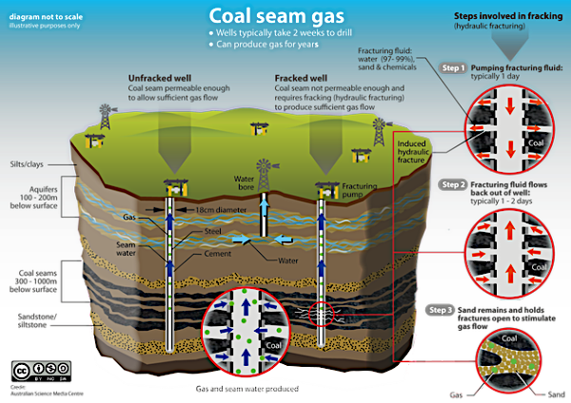
8. Discuss the reasons different groups in society may use or weigh criteria differently to evaluate claims, explanations or prediction in making decisions about contemporary issues involving interactions of the Earth’s spheres

ACTIVITY: Watch the following Youtube clips and answer the following questions

The Project: Coal Seam Gas Date: 21/2/13 (7:39)
https://www.youtube.com/watch?v=0sz9LHqEjiI

60 Minutes: Fracking - the Coal Seam Gas Land Grab Date: 15/6/11 (13:27)
https://www.youtube.com/watch?v=FUMtQUZyuis

- What is Coal Seam Gas? (4 lines)

- Outline the process of mining coal seam gas.

- Where can Coal Seam Gas be mined in Australia? (3 lines)

- Outline the issues involved with mining for Coal Seam Gas. (at least 15 lines)

- Who has the greatest power in this issue? Justify your answer. (3 lines)

- Consider the advantages and disadvantages of opening up a coal seam gas mine where you live. (at least 10 lines)

- Complete the table below:

Name of Person  (The Project) | Role | Opinion
* Megan Baker | Farmer
* Dayne Prtasky | Coal Seam Gas Campaigner and local
* Dr Mariann Lloyd-Smith | Chemical expert
* Stirling Hinchliffe | Queensland Mines Minister

Name of Person  (60 minutes) | Role | Opinion
# Peter Shannon | Bush lawyer
# Unknown | Gas company
#Stephen Robertson | Queensland Mines Minister
# Gavin Mudd | Hydrogeologist from Monash University
Kate Woodhouse | Owner of Wildlife Sanctuary

