What is our Universe made of?

Part 1: Watch the youtube video “What is the Universe made of?” to answer the following questions.
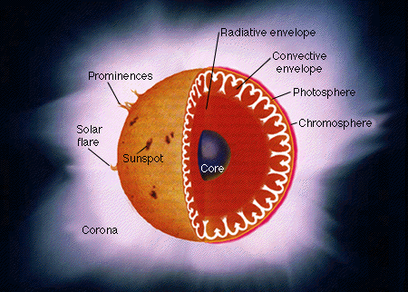

Inside the Sun

- What object in the Universe has made all the molecules present today?

- Describe briefly the “Big Bang”

- List the two elements that the early Universe was composed of?

- Explain how stars are formed?

- How do stars produce light?

- Stars are a careful balance between two forces – Gravity and Radiation. Draw a diagram to illustrate this.

- Massive stars can make all the elements of the Periodic Table up to?

- Identify what happens to large stars when their nuclear fuel runs out.

- How are the heavier elements in the Periodic Table formed?

- Describe how planets like Earth are formed and how are they different to stars.

Everything is made of atoms that were created inside stars – even human beings.
Part 2: Building a Solid Picture of what our Universe is filled with.

Use the internet, your textbook and other resources to respond to the following questions

Group of 4 | Group of 3
- Q11, 12 and 13  - Q 14 and 15  - 16 and 17  - 18 | - Q11, 12 and 13  - 14 and 15  - 16 and 18

- Outline what a nebula is.

- Provide the name and an image of a nebula.

- What is a galaxy?

- Draw a simple diagram of the Milky Way showing the spiral arms AND label where the Solar System is placed.

- Draw a diagram of the Solar System showing all EIGHT planets AND the asteroid belt.

- Why is Pluto no longer called a planet? What is its new definition? Hint: Your answer will need to identify the three conditions for an object to qualify as a planet.

- Draw a diagram of the inside of Pluto, showing what it is composed of AND the diameter of Pluto.

- Describe some other objects that are found in Our Universe

Possible website: http://www.universetoday.com/13573/why-pluto-is-no-longer-a-planet/

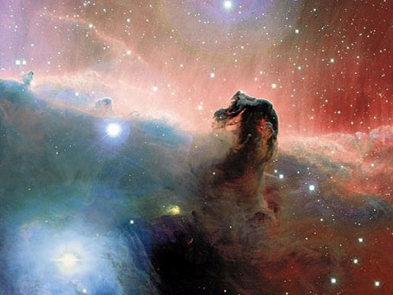
The Horsehead Nebula

