2.5) Looking at Star Spectra

Each star emits light at a range of different wavelengths that covers the entire range of the electromagnetic spectrum.

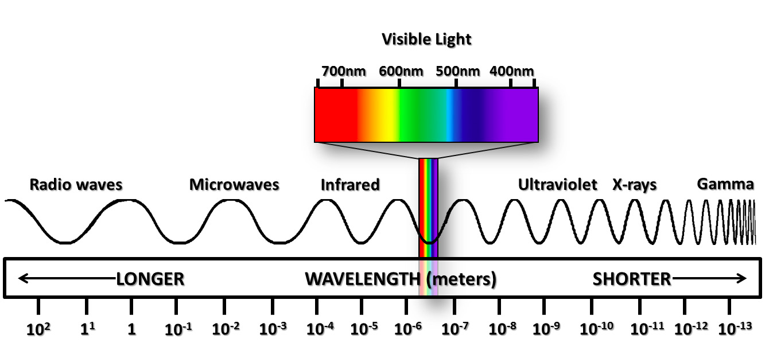
Scientists are very interested in the range of visible light colours that are emitted by stars and this is called the star’s spectra. Light from the star is viewed through different coloured filters. By comparing the magnitude of the star when viewed through different coloured filters, its precise spectrum can be determined. Here is an image of the Sun’s Spectrum

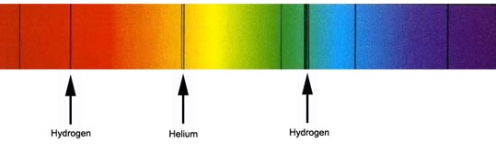

Information that can be determined from a Star’s Spectrum

1) Surface Temperature. Cooler stars emit most of their energy in the infrared and red parts of the spectrum and hence appear red. Very hot stars emit a lot of energy in the violet and ultraviolet parts of the spectrum and hence appear blue. Stars with surface temperatures in between these extremes emit light across a range of wavelengths and can appear orange, yellow or white. A device called a spectrometer can be used to split the light into its spectrum to reveal its component colours.
Below is a table showing how the predominant colour of the spectrum can identify the surface temperature of the star.

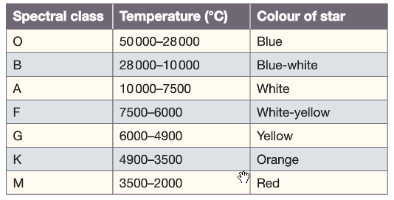

2) The Elements present in the Star. Scientists can also determine what chemical elements are present in a star from the position of black lines in the star’s spectrum. Elements in the star will absorb certain frequencies (or colours) of light and hence black lines appear in the spectrum.

Go to the following website, READ the information and see if you can identify the elements in the star given.

http://www.learner.org/teacherslab/science/light/color/spectra/index.html

3) The Movement of the Star: Regularly these black lines are in the same pattern but not in the correct position. In other words they are all shifted towards the red end ie Red Shifted OR they are all shifted towards the blue end ie BLUE Shifted. This is due to the movement of the star and a scientific concept known as Doppler Effect.
