Stage 5 Skills – Set 2

Section 1) Writing Methods and Risk Assessment:

A) Sue wants to test if the plants need more WARMTH, LIGHT and WATER.

- Set up the experiment with three identical pots, each containing three identical plants. Use the same type and amount of soil for each pot.
- Shine a lamp onto the three pots to provide good light
- Place a heater near the pots to maintain an approximate ambient temperature of 20º C
- Water each pot with 50 mL of tap water, every third day.
- Each day, measure and record the height of the plants. Continue to collect data for 14 days

b) Two risks and their associated precaution could be:

- Slip on any water spilled on the floor and injure back or sprain ankle – precaution is to be careful when watering plants and wipe any water off the floor
- Burn from light lamp – precaution be careful to not touch lamp and place lamp and plants on a bench where they can be easily seen

Question B

- The Amount of Bubbles produced by Washing Up liquids
- Place 20 mL of water and 5 mL of Sudsy washing up liquid into a boiling test tube using a plastic pipette and then place a rubber stopper in the test tube
- Invert the test tube 20 times and measure the height of the bubbles produced
- Record the data in a table
- Repeat steps 1 and 2 three times and record the average of these three results in a table
- Repeat steps 1 – 3 to determine the height of bubbles produced for three other washing up liquids

- There is a risk of cutting finger on broken glass if test tube is dropped. The precaution would be to be careful while inverting test tube and place in a test tube rack.

Section 2) Drawing and Analysing Graphs - Answers

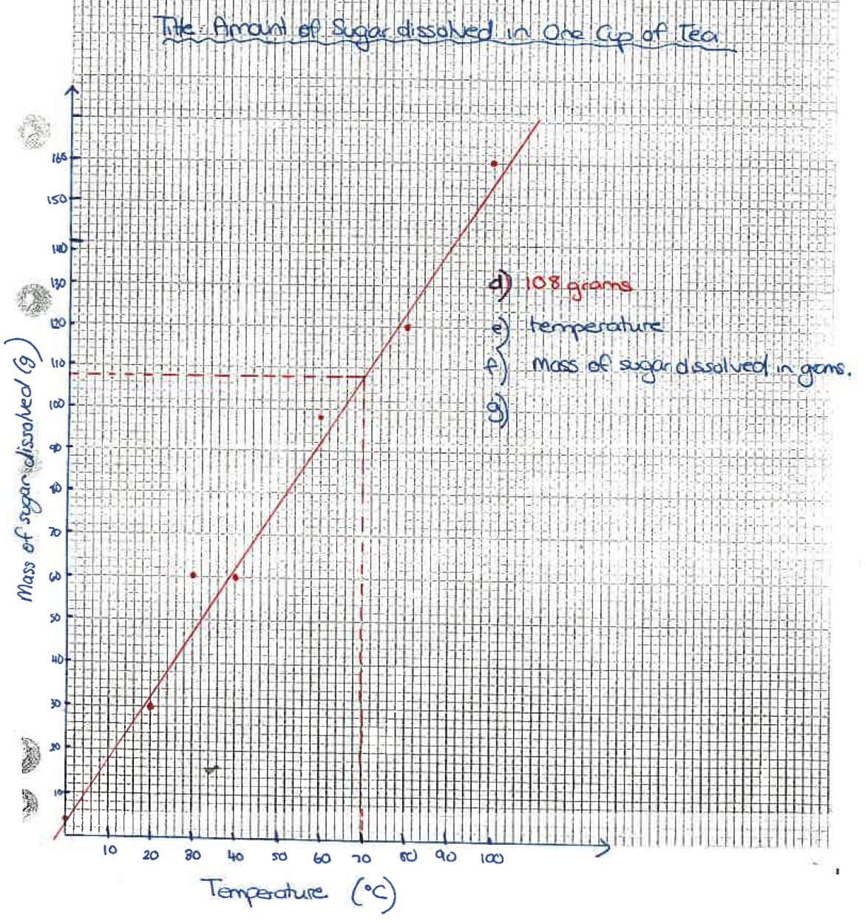
- Drawing a Line Graph a) – c)

- see graph
- 108 grams
- temperature
- mass of sugar dissolved in grams
- same type of cup, same cup size, same concentration of tea, same type of tea, same method of stirring
- Not all variables were controlled and hence it was not a fair test
- This experiment is not reliable as it was not repeated at least three times

2) a) The purpose of this experiment was to determine the rate of the reaction for three different acids

- C
- A
- B and C as their temperature is dropping
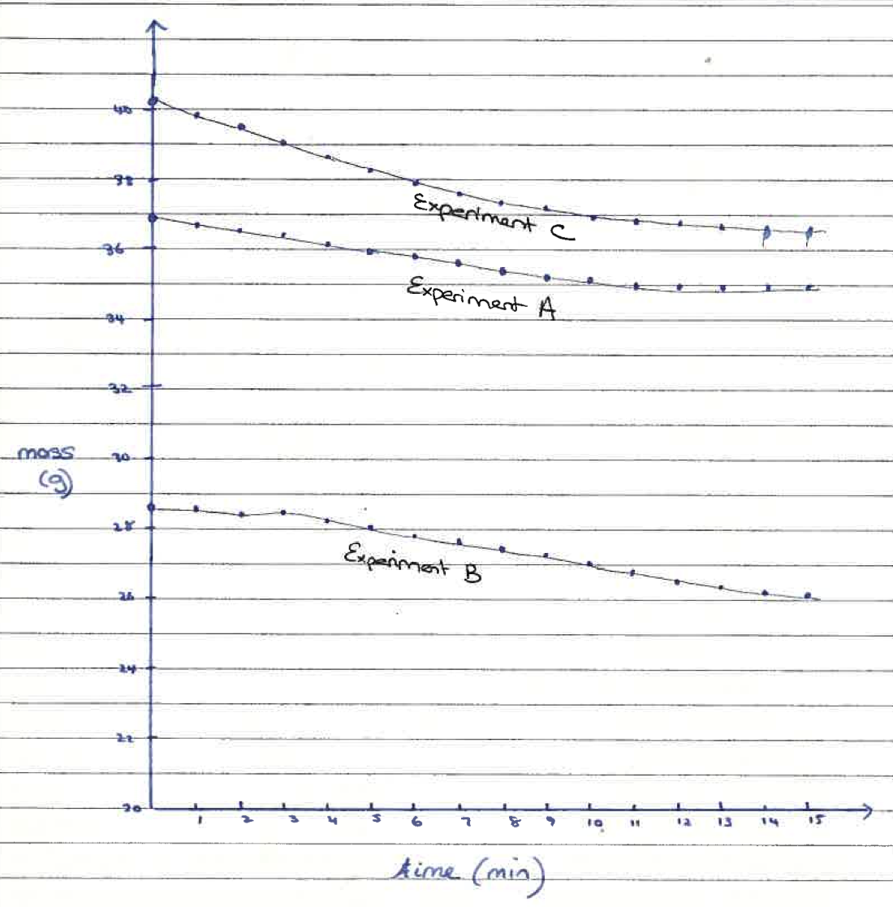
- Graph below

- the amount of each acid, the amount of magnesium, the time between temperature measurements
- the type of acid
- The conclusion for this experiment is that acid C reacted the fastest as the maximum temperature was reached first
- This is not a fair test as not all variables were controlled such as concentration of acid and container size was not indicated.
- This experiment is not reliable as each acid was not tested at least three times and the average calculated

