Experiment: Day and night across the Earth

Aim: To model the day/night cycle

Equipment
polystyrene (or similar) sphere (about the size of a small rockmelon)
metal or wooden skewer
pen
spotlight or bright torch

Method:
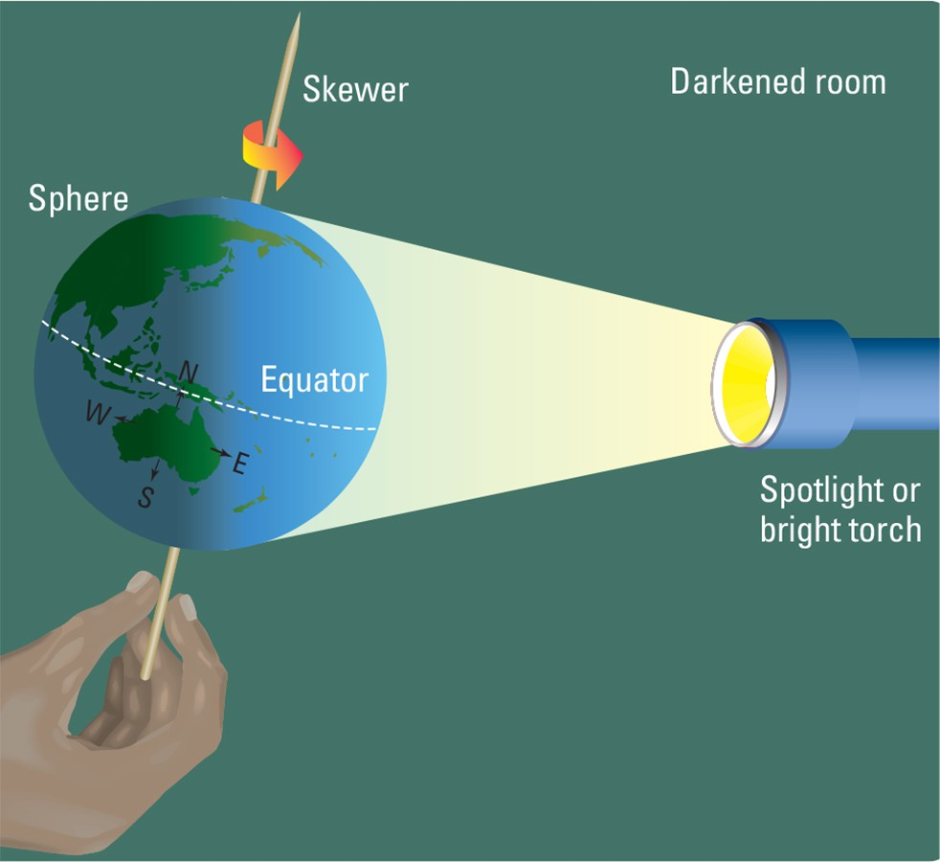
- Your sphere represents the Earth. Draw a line around the centre to represent the equator. Label the Northern and Southern Hemispheres and mark in the North and South Poles.

- Draw an outline of Australia and Africa on your sphere. Use an atlas to check the positions and approximate shape of each continent. Also note the position of north.

- Mark the four compass directions — north, south, east and west — around the outlines of each continent.

- Gently push a skewer through the centre of your sphere from bottom to top through the ‘polar regions’. This skewer represents the Earth’s imaginary axis.

- Do this experiment in a darkened room. This will help you see more clearly the contrast between light and dark.

- Turn on the spotlight in a dark room. Its light represents the sun’s light. Hold the skewer so it leans a little away from the vertical. This represents the Earth’s tilt.

- Turn your sphere very slowly in the light, making sure you keep the skewer slightly tilted all the time. Turn it in an anticlockwise direction (as seen from above). Watch what happens from side on.

DISCUSSION
- In which direction is the ‘Earth’ rotating — from east to west or west to east? Check the compass directions you marked on your sphere.
- In which direction does the ‘sun’s’ light seem to move around the ‘Earth’? How does this explain the apparent movement of the sun across the sky?
- Where is Africa when Australia is lit up? Where is Australia when Africa is lit up? Explain why these continents experience daylight at different times.
- How does this experiment help to explain why night falls in Perth about two hours later than in Sydney?

