Danebank

Year 9 Science

Practise Paper

Name: ______________________________

Teacher: ______________________________

Date:

Time Allowed:

Weighting:

Instructions  - Attempt all questions  - Board approved calculators may be used.  - Write using black pen.  - Draw diagrams using pencil.  - This paper must not be removed from the Examination Room.  - Leave all equipment as you found it when you move to your next task. | Activity 1 (6 marks)  - pages 2-3  Activity 2 (7 marks)  - pages 4-5  Activity 3 (7 marks)  - pages 6  Total Marks:

Activity 1 (6 marks)

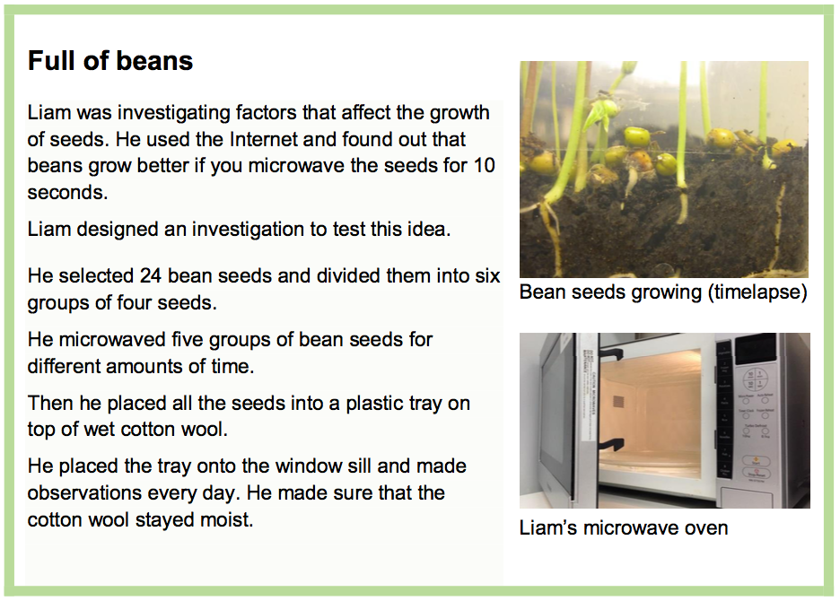

- Liam did not microwave one group of 20 seeds because
- he did not have enough time
- he was using the leftover seeds
- he needed to make sure he had enough seeds growing
- he wanted to see if the seeds grow without microwaving

- Which variable in Liam’s investigation did he purposely change?
- type of seeds
- amount of water
- amount of growth
- time in microwave oven

Use the following diagram to answer questions 3, 4 and 5.

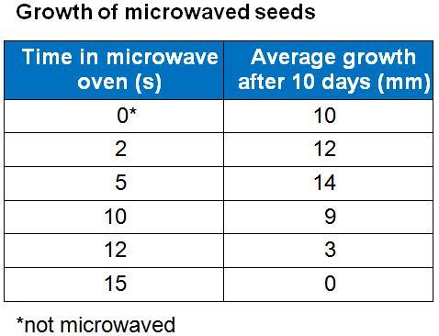

- To measure average growth, Liam probably made measurements of the
- width of the plants
- length of the plants
- number of plant roots
- number of plant leaves

- Identify one trend shown by Liam’s results.
- Microwaving seeds for 10 seconds will kill them.
- Microwaving seeds for more than 10 seconds will increase their growth rate.
- Microwaving seeds up to 5 seconds will increase the amount of growth over 10 days.
- Microwaving seeds up to 5 seconds will decrease the amount of growth over 10 days.

- What is a suitable conclusion for this investigation?
- Will microwaving of seeds improve their growth?
- All seeds will have increased growth after microwaving.
- Microwaving seeds does not necessarily increase the amount they grow.
- Seeds microwaved for 5 seconds grew to an average of 14 millimetres after 10 days.

- Liam will write a report on this investigation. What will Liam include in his bibliography?
- the equipment list
- his list of references
- his discussion and conclusion
- the background notes (information) he collected

Activity 2 (7 marks)

Some students were given a large container of hot water and three identical cans, except that one was painted white, one blue and one black.
They were asked to design and conduct an experiment to see how the colour of the can affected the rate at which water it contained cooled down.

- The table shows one student’s equipment list. 1

Complete the last row of the table to show the other piece of equipment needed to collect results for the experiment and its reason for use.

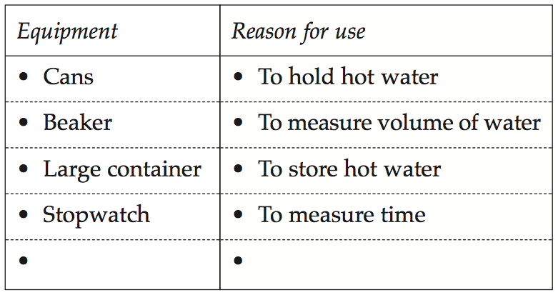
- Thermometer. * To measure the temperature
of the water

- One of the pieces of equipment used in the student’s experiment should have been replaced by a different piece.

- Which piece should be replaced and what should it be replaced by? 1

The beaker should have been replaced with a measuring cylinder

- Explain your answer. 1

The beaker should have been replaced with a measuring cylinder as the measuring cylinder will determine the amount of water far more accurately than the beaker.

- Except for colour, the cans are identical. Name ONE other factor that would need to be controlled in this experiment. 1

SAME amount of water, SAME type of water, SAME stopwatch, SAME size beaker

- Name the independent variable. 1

The colour of the can

- The graph shows the results of the student’s experiment.

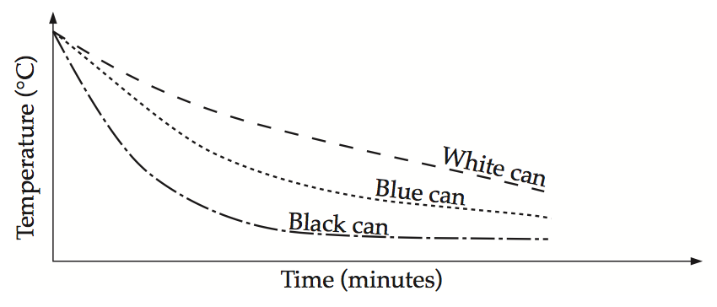

Write a conclusion for the experiment. 1

The rate of cooling of the water in the black can was greater than the blue or the white can.

- The experiment was repeated using three identical black cans X, Y and Z.

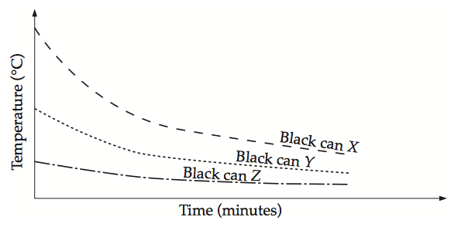

What was the aim of the experiment? 1

To determine if the starting temperature of the water affected the rate of cooling

Activity 3 (12 marks)

A student was interested in finding out how exercise affected her heart rate. She went to the gym and carried out the following experiment. She ran on the treadmill at a speed of 10km/h for 20 minutes. With her hands on the pulse sensors she was able to monitor her heart rate as she ran. Before she started the treadmill her heart rate was 60 beats per minute. After 2 minutes it was 77. At 4 minutes, 94. At 6 minutes 110. At the 8 minute mark her hands came off the sensors and she missed the reading. At 10 minutes it was 145. At 12 minutes, 162. At 14 minutes, 179. At 15 minutes it reached 190 and stayed at that rate until the 20 minute mark.

- Rule up a table of her results.
Time  (minutes) | Heart Rate  (Beats/minute)
0 | 60
2 | 77
4 | 94
6 | 110
8 | -
10 | 145
12 | 162
14 | 179
16 | 190
18 | 190
20 | 190

- Plot this data on the graph paper (include a line of best fit).

Heart Rate (Beats/minute)
- What was the aim of the experiment?

To determine the effect of running on heart rate
- What was the independent variable?

Time

- What was the dependent variable?

Heart rate in beats per minute

- List 2 variables that would have to be controlled.

SAME pace of running, SAME Treadmill, SAME pulse sensor

- Estimate what her heart rate would have been at the 8 minute mark using your line of best fit.

128 beats per minute

