Scientific Report Writing in Years 9-10

- Aim
- The aim is the purpose of an investigation
- It begins with a verb; for example, “to investigate; to measure; to collect”

Example
To determine whether the temperature of water affects the time it takes for a stain to disappear when soaked in bleach.

- Hypothesis
- A predictive statement that can be tested

Example
An increase in temperature will result in the stain disappearing quicker.

- Materials list
A materials list or equipment list should have the following:
- a list of materials and/or equipment used.
- equipment sizes (where appropriate) e.g. 100mL measuring cylinder.
- quantities (where appropriate) e.g. 6 x white cloth, 10cm x 10cm

Example
- 6 x white cloth, 10 x 10cm
- red food dye
- 5 L bucket
- water: 20°C, 25°C, 30°C, 35°C and 40°C
- bleach
- teaspoon
- 100mL measuring cylinder
- Stopwatch

- Risk assessments
Risk assessments should:
- identify hazards or risks in the experiment that can cause injury or harm
- describe how the individual hazards or risks are minimised.

Risk | How it is minimised
splashing bleach onto skin or in eyes | - wear safety glasses  - wear gloves
Scalds from hot water | - use water that is below 45°C
Example

- Method Writing
The method should be clear enough that Someone else should be able to read it and repeat it exactly.
Methods should have the following characteristics:
- Written in the present tense.
- Each step starts with a verb.
- No personal pronouns (you, I, he, we, she, they, etc.)
- include specific amounts and units
- show that the investigation was fair/valid.
- include repetitions
- specify what is being measured/observed/recorded and how.
- Include any calculations that were performed

Example
- Add 1 teaspoon of red food dye to each piece of cloth and spread evenly over a 5cm x 5cm area. Allow to dry.
- Fill a bucket with 5L of water at 20°C. Use measuring cylinder to add 100 mL of bleach to bucket.
- Submerge the first cloth and record the time it takes for the stain to disappear.
- Repeat steps 3 and 4 for 25°C, 30°C, 35°C and 40°C.
- Repeat the entire experiment four more times and average the results.

- Representing data

Tables
Tables should:
- have a descriptive title which includes both the dependent and independent variable
- have the independent variable in the first column
- have a column heading for each column which includes units (where applicable)
- units in the heading only (only data in rows of table)
- include averages in the final column (where applicable)
- averages are reported to be consistent with the data they collected

Example
Table 1: The time it took for the stain to disappear at different temperatures.

Temperature (°C) | Time it takes for stain to disappear (seconds) |  |  |  |  | Average
 | Trial 1 | Trial 2 | Trial 3 | Trial 4 | Trial 5
20 | 35 | 39 | 40 | 37 | 39 | 38
25 | 29 | 34 | 27 | 32 | 28 | 30
30 | 20 | 24 | 22 | 21 | 23 | 22
35 | 17 | 14 | 14 | 17 | 13 | 15
40 | 10 | 9 | 11 | 11 | 9 | 10

Line graphs
- axes appropriately labelled with the independent variable on x-axis and dependent variable on y-axis
- an even scale on both axis which uses most of the graph
- accurately plotted data points
- an appropriate line or curve-of-best-fit
- a descriptive title that includes both independent and dependent variable.
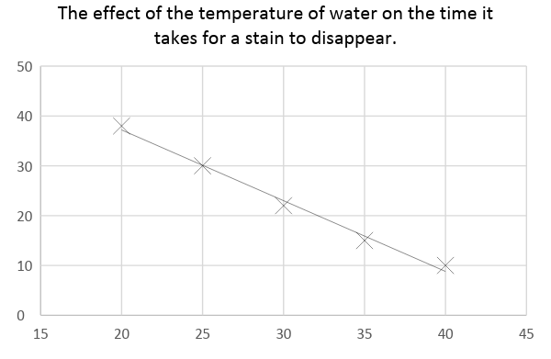
Example

- Analysing Data - When analysing data, you may be asked to:
- identify general trends in the results. In other words what happens to the independent variable when the independent variable increases? Does it increase, decrease or stay the same. For example, as the temperature of the water increases, the time it takes for the stain to disappear decreases.
- Compare results to published data

- Discussion - In a discussion, you may be asked to:
- Describe your results
- Connect your results with theory
- identify sources of error
- suggest improvements to the experiment
- describe the accuracy, validity and reliability of the experiment
Term | Definition | Examples
Accuracy | How close the data is to the true value | Accuracy is affected by the equipment that is used and how it is used. For example a measuring cylinder is more accurate than measuring volumes with a beaker
Reliability | The data collected is similar for each repeated measure | A reliable investigation needs to be repeated at least 5 times AND consistent results obtained.
Validity | The extent to which the test measures what was intended | A Valid investigation includes  - controlled variables and when appropriate an experimental control  - Did the method test the aim?  - Was the experiment reliable?

- Conclusion
- An overall statement that summarises the trends in the results and relates back to the aim.

For example,
The temperature of water does affects the time it takes for a stain to disappear when soaked in bleach. As the temperature increases, the time it takes for the stain to disappear decreases.

