Skills – Set 2

Section 1) Writing Method and Risk Assessment:

Question A) Look at the diagram below.
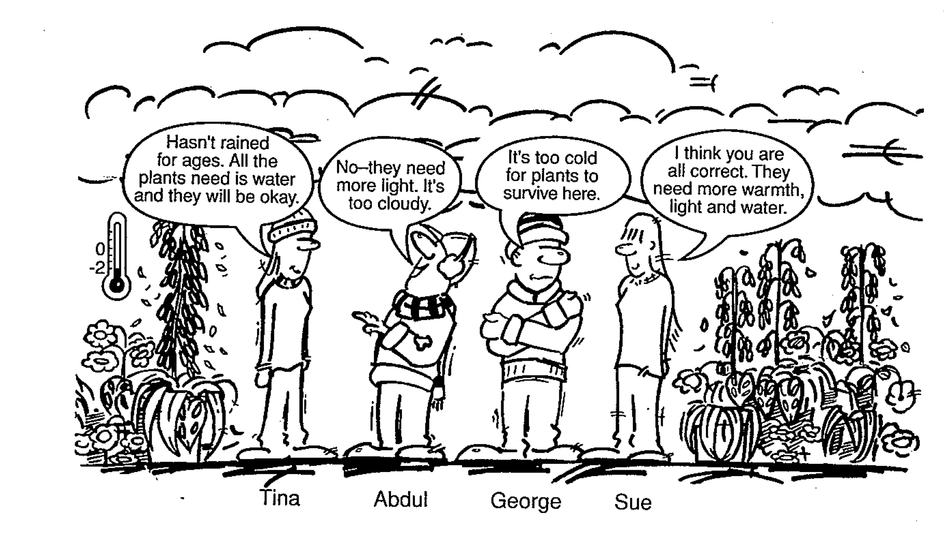

- Write a method for an experiment that would test Sue’s idea.

- Describe two risks that could be present when conducting your experiment and include the safety precautions that could be employed to reduce each risk.

Question B (5 marks) Marks

Luke and Olivia saw an advertisement for ‘Sudsy’ washing-up detergent, claiming that it makes more bubbles than other washing-up liquids. They decided to do an investigation comparing the amount of bubbles produced by ‘Sudsy’ and three other washing-up liquids when shaken.

(a) Describe an experimental procedure for their investigation, in order to collect valid data. 4

(b) Describe ONE precaution they should take to reduce the risk to themselves. 1

Section 2) Drawing and Analysing Graphs

- Drawing a Line Graph.

A student conducted an experiment to see how temperature affected the amount of sugar that would dissolve in a cup of tea. Each cup contained the same volume of tea and the sugar was stirred in at an equal rate for each cup. Only one cup was tested for each temperature.

Amount of sugar dissolved in one cup of tea

Temperature (ºC) | Mass of sugar dissolved (g)
0 | 4
20 | 30
40 | 60
60 | 98
80 | 120
100 | 160

- Write a suitable aim for this experiment.

- Using the graph paper provided, draw a label appropriate axes and give the graph a title

- Plot the values on your graph using points to mark each place.

- Draw a line of best fit, that is, a line drawn in between the points so that some are on the line, some are below it and some are above.

- What was the mass of sugar dissolved at 70º according to your graph?

- Name the independent variable.

- Name the dependent variable.

- List the variables that should be controlled in order for this to be a good experiment.

- In a fair scientific test, all variables are controlled. Is this experiment a fair test of the solubility of sugar?

- A reliable experiment is when it has been repeated at least three times and provides consistent results. Is this experiment reliable? Justify your response

- Outline how this experiment could be improved.

- Using Graphs to Analyse Experiments

Some students did an experiment in which they added 20 mL of three different acids to 5 g of magnesium in three different containers labelled A, B and C. They measured the temperature of the mixture in each container each minute. Part of their experimental record is shown in the table below.

Time  (min) | Temperature (ºC)
 | A | B | C
0 | 18.2 | 18.6 | 18.2
1 | 18.4 | 18.7 | 18.5
2 | 18.5 | 18.9 | 18.7
3 | 18.6 | 19.0 | 19.0
4 | 18.8 | 19.2 | 19.4
5 | 18.9 | 19.3 | 19.5
6 | 19.1 | 19.5 | 19.8
7 | 19.2 | 19.7 | 20.1
8 | 19.3 | 20.0 | 20.4
9 | 19.5 | 20.2 | 20.7
10 | 19.6 | 20.5 | 21.1
11 | 19.8 | 20.7 | 20.9
12 | 19.9 | 20.9 | 20.8
13 | 20.1 | 20.7 | 20.6
14 | 20.2 | 20.6 | 20.4
15 | 20.4 | 20.4 | 20.1

- Write a suitable aim for this experiment.

- Which acid seems to have reacted fastest with the magnesium? How do you know?

- Identify acid reacted the slowest?

- Did any of the acids completely react with all the magnesium? How do you know?

- Draw, on the same axes, a graph to represent the results of this experiment.

- What factors are controlled in this experiment?

- Identify the independent and the dependent variables.

- Write a conclusion for the experiment based on your interpretation of the results.

- Is this a valid method? Justify your response

- Is this experiment reliable? Justify your response

