Stage 5 Skills – Set 2

Section 1) Writing Methods and Risk Assessment:

Question A)

- Sue wants to test if the plants need more WARMTH or LIGHT or WATER.

- Set up the experiment with two identical pots, each containing three identical plants. Use the same type and amount of soil for each pot. Use tomato plants that are approximately 15cm in height
- Place the pots in the same position so that they are receiving the same amount of sunlight and warmth.
- Give each plant 50 mL of water every day
- Shine a white light lamp onto the one pot to provide good light for 4 hours each day from 9 am to 1 pm
- Measure the height of the plants using a ruler each day.
- Record the data in an appropriate table
- Continue to collect data for 14 days.

b) Two risks and their associated precaution would be

- You could contract legionella disease from the potting soil mix so make sure that you wear a mask and use gloves when handling potting mix
- You could slip on any puddles of water and receive bruises or even break a bone so make sure that all spilt water is cleaned up straight away

Question B)

a)
- Place 10 mL of “Sudsy’ washing-up detergent into a 50 mL measuring cylinder
- Add 20 mL of distilled water into the same measuring cylinder
- Stir gently with a stirring rod until thoroughly mixed together and without creating any bubbles
- Place a rubber stopper on the large test tube and shake vigorously for 20 seconds
- Measure the height of the bubbles in mL by using the measuring cylinder’s graduations
- Record the data in an appropriate table
- Repeat steps 1 – 6 another 5 times
- Repeat step 1 – 7 using two other brands of washing-up detergent

- You could slip on any puddles of water or detergent so make sure that all spilt water is cleaned up straight away

Section 2) Drawing and Analysing Graphs - Answers

- a) A suitable aim should contain independent and dependent variables – To determine the effect of temperature on the amount of sugar dissolved in tea

b) – d) Drawing a Line Graph

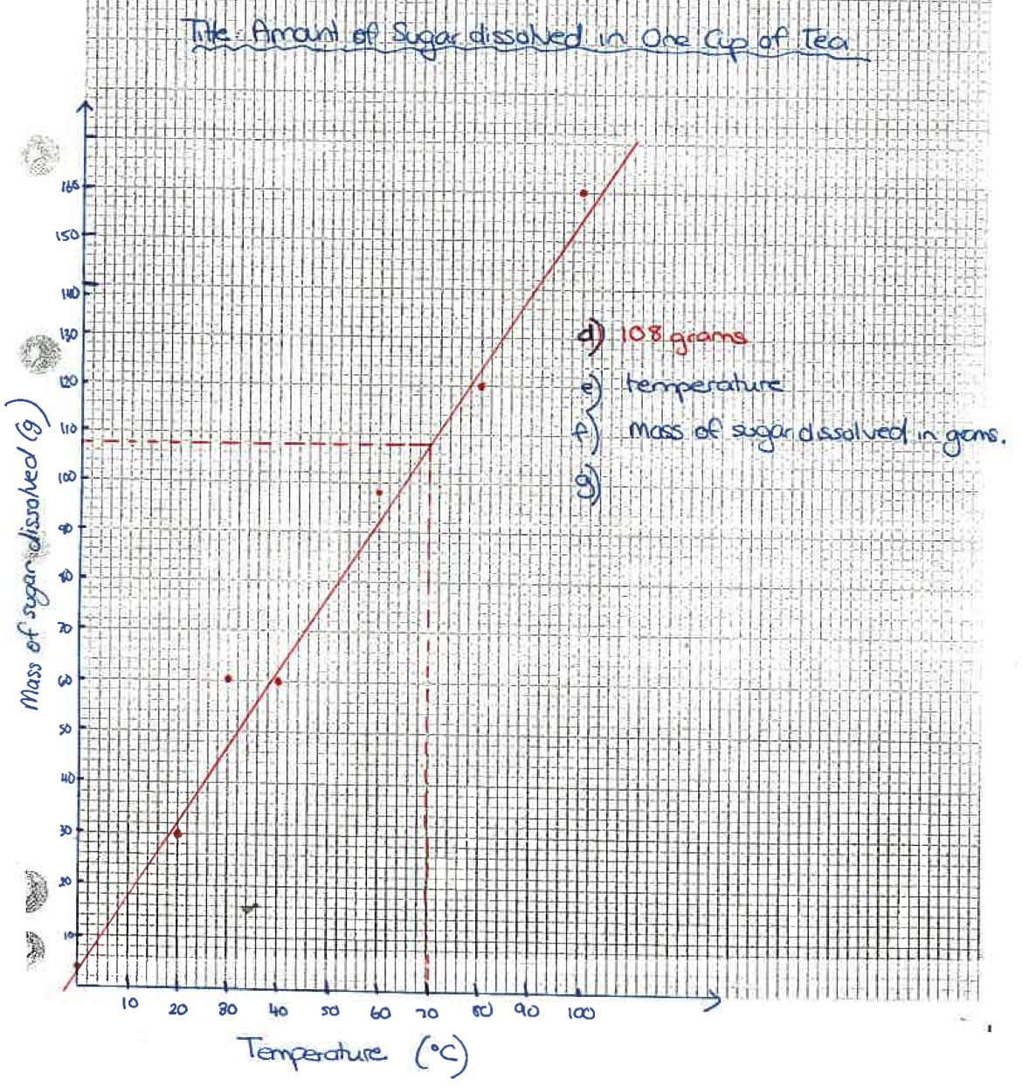
e) 108 g
f) temperature
g) mass of sugar dissolved in grams
h) same type of sugar, same size cup, same type of tea, same concentration of tea, same stirring technique,
i) Not all variables are controlled hence it is not a fair test
j) It is not reliable as it was only conducted once
k) use an electronic balance to measure the mass of sugar or use a data logger to accurately measure the temperature of the water

Question 2

- To investigate which acid reacts the fastest with magnesium

- Acid C appears to have reacted the fastest as it reaches a max at 10min of 21.1oC and then decreases after that.

- Acid A appears to be the slowest as at 15 minutes it still is reacting and getting warmer

- Acid B and C appears to have completely reacted as their temperatures have started to decrease.

- See graph on next page

- Same strength of each acid, same amount of magnesium strips, same initial temperature of each acid, same sized test tube

- The type of acid was changed

- Conclusion – The acid that reacted the fastest was Acid C as this acid reached a maximum temperature of 21ºC first at 10min.

- This experiment is not a fair test as a fair test must be valid. To be valid, four things are required:

- Must be reliable and hence repeated 5 times and consistent results achieved. However it was not repeated
- Must be accurate – it is accurate
- Must be a suitable method that is well designed with as many as possible variables controlled – cannot determine this from the information provided
- The method must test the aim – it does

- It is not reliable as it was only conducted once.

