How can we stop the rise of the Superbug?

Group Members:

PBL Content

Part 1: The Stimulus - Rise of the Superbugs
Part 2: Preliminary Research - What are Superbugs?
Part 3: Immerse Yourself in the Science of Superbugs
Part 4: The Superbug Project

Suggested Timeline

Lesson | Tasks to achieve | Student  Check | Teacher Check
1  wk 4,  27/10 | Part 1. The Stimulus – Rise of the Superbugs  - Watch stimulus video and create mind map  Part 2. Preliminary Research – “What are Superbugs?”  - Before the end of lesson, delegate articles to all members of the group and complete summaries for homework. | Part 1 | Part 1
2  29/10  (1 hour) | Part 2. Preliminary Research – “What are Superbugs?”  - Group discussion and enter information into Google doc (suggested time for activity 20 mins )  Part 3) Immerse Yourself in the Science of Superbugs – Where did Superbugs come from?  - Task A) The Story of the Earth – watch as much as possible | Part 2 | Part 2
30/10 | Professional Development Day
3  wk 5,  3/11 | Part 3) Immerse Yourself in the Science of Superbugs – Where did Superbugs come from? - continued  - Task A) The Story of the Earth – finish watching this documentary and then fill in evolution table  - Task B) Time Line Challenge | Task A | Task A
 |  | Task B | Task B
4  6/11 | Part 3) Immerse Yourself in the Science of Superbugs – Where did Superbugs come from? - continued  - Task C) The Current Theory of Evolution – read, watch and summarise.  - Task D) Natural Selection – The Process by which Evolution takes place. Create a flow chart. This activity must be completed for homework for Tuesday. | Task C | Task C
 |  | Task D | Task D

Suggested Timeline - continued

Lesson | Tasks to achieve | Student Check
5  wk 6, 10/11 | Part 3) Immerse Yourself in the Science of Superbugs – Where did Superbugs come from? - continued  - Final Task) How are we causing the rise of the Superbug? – open research
6  12/11  (1 hour) | Part 4) The Superbug Project – How can we stop the rise of the Superbug?  - Chose profession and research for Education Kit
13/11 | - Year 10 Science Ignite Day
7  wk 7, 17/11 | - Continue working on “Education Kit”
8  20/11 | - Continue working on “Education Kit” and start working on Presentation to the class
wk 8, 24/11 | Year 10 English, Drama and Art Day
9  26/11 | - Continue working on “Education Kit” and complete work on Presentation to the class
27/10 | Year 10 Careers Day
10  wk 9, 1/12 | - Final day to working on “Education Kit” and rehearse your Presentation to the class  - Teacher may choose to start Presentations today
11  4/12 | - Presentations
12  wk 10, 8/12 | - Finish Presentations and end with Superbug Game Show or Fun Activities
Teacher check-ins and verbal feedback:
There are some points where you are required to check-in with your teacher, discuss your ideas with them and seek verbal feedback before you continue. These should occur during Part 1, Part 2, Task A, Task B, Task C and Task D. When each section is completed, check as done and then have your teacher sight and check off.

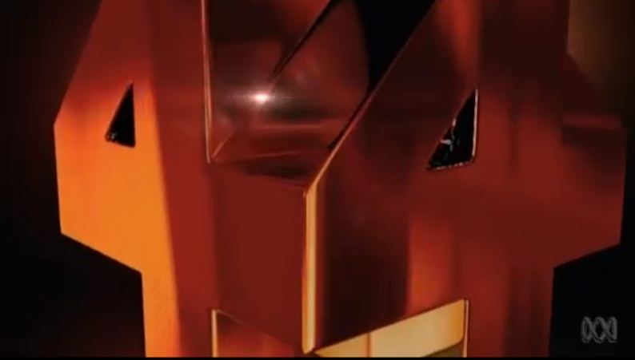
Part 1: The Stimulus - Rise of the Superbugs

A) Watch the outstanding documentary by Four Corners called "Rise of the Superbugs". Record as much information as possible about Superbugs.

Part 1: The Stimulus - Rise of the Superbugs

B) Photograph of Preliminary Mind Map

Part 2: Preliminary Research – “What are Superbugs?”

A) Each member of your group is to work through one or two of the resources provided below and record any important information about Superbugs. You may include any other resource such as textbooks and scientific websites to build or clarify your general understanding of Superbugs. It is important that you source any additional websites, books or images that have been used.

Article | Team Member | Done

Additional References | Team Member | Done

B) Your group should then discuss, record and organise the information obtained about Superbugs in the google doc. During this discussion, students should ask questions from their peers or from their teacher so that any gaps in their understanding are resolved. This is an important activity to demonstrate persistence in learning of individuals as well as the collaborative ability of the group to listen, reflect and support the learning of all members.

Part 3: Immerse Yourself in the Science of Superbugs?”

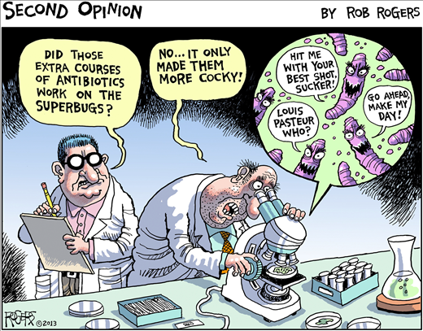

This section consists of 5 mandatory tasks:

Task A) National Geographic Documentary – The Story of the Earth
Task B) Time Line Challenge
Task C) The Current Theory of Evolution
Task D) Natural Selection – The Process by which Evolution takes place
Final Task) How are we causing the rise of the Superbug?

There are also some extension tasks that groups can complete if they have time to do so

Task E) The Evidence supporting Evolution
Task F) Fossils and the Law of Superposition

Task A) National Geographic Documentary – The Story of the Earth

Watch the video "The Story of the Earth" and use the video to fill in the Evolution Table below.

4600 mya
4540 mya
3900 mya
3800 mya
3500 mya
540 mya
375 mya
250 mya
200 mya
65 mya
47 mya
4 mya
1.5 mya
200,000 years ago

Some of the animals and plants mentioned in “The Story of the Earth” that need to be placed in your evolution table:
Stromatolites,
Trilobites
Opabinia
Anomalocaris
Wiwaxia
Pikaia
Gorgonopsians and Scutosaurus
Ichthyosaurus and Plesiosaurus
“Ida” – lemur-like
Homo erectus
Homo sapian

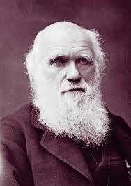
Task C) The Current Theory of Evolution

Fossils show us that life on Earth has changed over time. Some species such as the dinosaur have become extinct. New species have arisen as well. Evolution has occurred. How has this happened? What is meant when we state that a species has evolved? The following resources must be used to build your picture of the Current Theory of Evolution and create summary notes on what you have learnt. Other resources can be used to further develop your knowledge.

- Summary Notes from Science Focus

- Summary Notes from the YouTube video “What is Evolution?”

- Additional Information

Task D) Natural Selection – The Process by which Evolution takes place!

i) Create a flow chart that demonstrates the processes involved with Natural Selection using websites, textbooks and the video "Natural Selection" by Stated Clearly

Task D) Natural Selection – The Process by which Evolution takes place!

ii) Complete the Experiment: Modelling Natural Selection using Jelly Beans
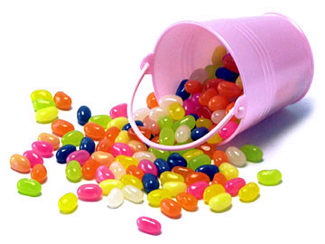
Equipment:
- sheet of clean paper to put your jellybeans on
- packet of jellybeans
- plastic ice cream tub for the class
- calculator
Method:
1. Separate all of the jellybeans into the different colour and count the number of each different coloured jellybean. Record your results in the table below.
2. Calculate the percentage of each colour by dividing the number of the separate colours by the total number of jellybeans and multiplying by 100.
3. Wash your hands and the teacher will give you five jellybeans – do NOT eat yet!!!!!
4. Pick out only two of your favourites from these five (yes, you can eat them, or just put them aside).
5. Return your remaining three jellybeans to the container with the rest of the jellybeans.
6. Repeat this three times. Each student (predator) should have preyed on (eaten!) six jellybeans.
7. Count up the remaining beans, and calculate again the percentage of each of the colours
Colour | At the start |  | After 3 ‘generations’
 | Number | Percentage of total | Number | Percentage of total
TOTAL |  | 100 |  | 100

Discussion:

1. Were all jellybeans of all colours consumed equally?
a) How do you know?

b) Why did this happen?

2. Natural selection requires a ‘selection pressure’ to cause the characteristics of the species to change. What was the selection pressure in the jellybean model?

3. Natural selection results in a population that is better adapted from the environment. How is this demonstrated in the jellybean model?

4. Assuming that the environment remained constant, what might happen to the jellybean population over time?

5. Natural selection requires variation among the members of a population. How is this represented in the jellybeans?

What have you learnt?

Final Task) Open Investigation - How are we causing the rise of the Superbug?

Now that your group has a better understanding of the scientific concepts involved, revisit your preliminary mind map and conduct further research to develop a thorough response to this question.

Each member must enter their research into their table below.

The group must constantly collaborate through out this task so that class time is used most effectively.

Team Member =
Identified Cause | Extra Details (include supporting data) | Source

Team Member =
Identified Cause | Extra Details (include supporting data) | Source

Team Member =
Identified Cause | Extra Details (include supporting data) | Source

Team Member =
Identified Cause | Extra Details (include supporting data) | Source

Part 4) The Superbug Project –
How can we stop the rise of the Superbug?

Now that your group knows the various causes of Superbugs, they need to use this knowledge to educate and support the community in their fight against this terrible problem. This is your chance to produce something that can help solve a REAL GLOBAL problem.

You group will produce and present to the class an EDUCATION KIT that contains a possible STRATEGY or PRODUCT (or both) that could stop the rise of the Superbug. Firstly your group must chose a specific profession and identify their target audience. For example, it could be a Professor in Medical Science who wants to inform/educate General Practitioners about what they can do to stop the rise of the Superbug. The Professor will use the EDUCATION KIT to educate the General Practitioner.

Possible professions and their target audience could be
- Journalists to inform the general public
- Pharmaceutical Representative to educate General Practitioners or Hospital Staff
- General Practitioners to educate their patients
- Teachers to educate students etc

Profession - |  | Target Audience -
Possible Solution  (a strategy or product) | Strengths of solution |  | Weaknesses of solution

Possible Solution  (a strategy or product) | Strengths of solution | Weaknesses of solution

Our EDUCATION KIT

1) Outline your proposed Education Kit – what does it contain?

2) Describe how the Education Kit works.

3) Describe how your Education Kit will help stop the rise of the Superbug

Task Rubric- How can we stop the rise of the Superbug?

Criteria | Highly Developed  3 marks | Developed  2 marks |  | Developing  1 mark
Content | - The Proposed strategy/product was plausible, innovative and strongly linked to stopping the rise of Superbugs | - The Proposed strategy/product was adequately linked to stopping the rise of Superbugs |  | - The Proposed strategy/product was weakly linked to stopping the rise of Superbugs
 | - The content was tailored to the target audience and to the intended purpose of informing, interesting or persuading. |  | - The presentation content and structure was tailored to the audience and to the intended purpose of informing, interesting or persuading. | - Attempts were made to tailor content to the target audience and to the intended purpose of informing, interesting or persuading.
 | - Strong inclusion of scientific concepts and relevant data to support claims |  | - Adequate inclusion of scientific concepts and relevant data to support claims | - Limited inclusion of scientific concepts and relevant data to support claims
Presentation | - Well organized and designed  - Clear and easily understood  - No use of palm cards and significant eye contact | - Content is organized to an acceptable level  - Message is sufficiently understood  - Some use of palm cards and little eye contact |  | - Content lacks organization  - Poorly designed  - Message not clearly understood  - Speakers relied on palm cards
Research Quality | - Uses a variety of sources | - Uses resources from similar sources |  | - Uses limited resources
 | - Uses reliable resources | - Sources have some reliability |  | - Questionable reliability of sources
Visual Appeal/ Creativity | - Imaginative; original  - Highly developed graphics | - Creativity is acceptable  - Use of graphics adequate to present message. |  | - Little creativity used  - Poor selection of graphics
TOTAL | /30 = %

