**Year 10 Skills Revision**

Question 28.

1. Thermometer – to measure the temperature
2. i) Beaker – measuring cylinder

ii) For more accurate measurement of the amount of water.

c) Various

d) The temperature of the water

e) A conclusion is a summary of the results of the experiment. A good conclusion will answer the aim AND identify whether the hypothesis was supported (using the trends of the data as proof). Hence:

* Colour affects the rate at which water cools down in the container with black cooling the fastest, then blue and finally white.

f) i) To see if the initial temperature of the water affects the rate at which water cools down.

ii) It does affect the rate – the higher the initial temperature, the greater the rate of cooling

Question 29.

1. **Sodium hydroxide**
2. **Is it a white solid?**

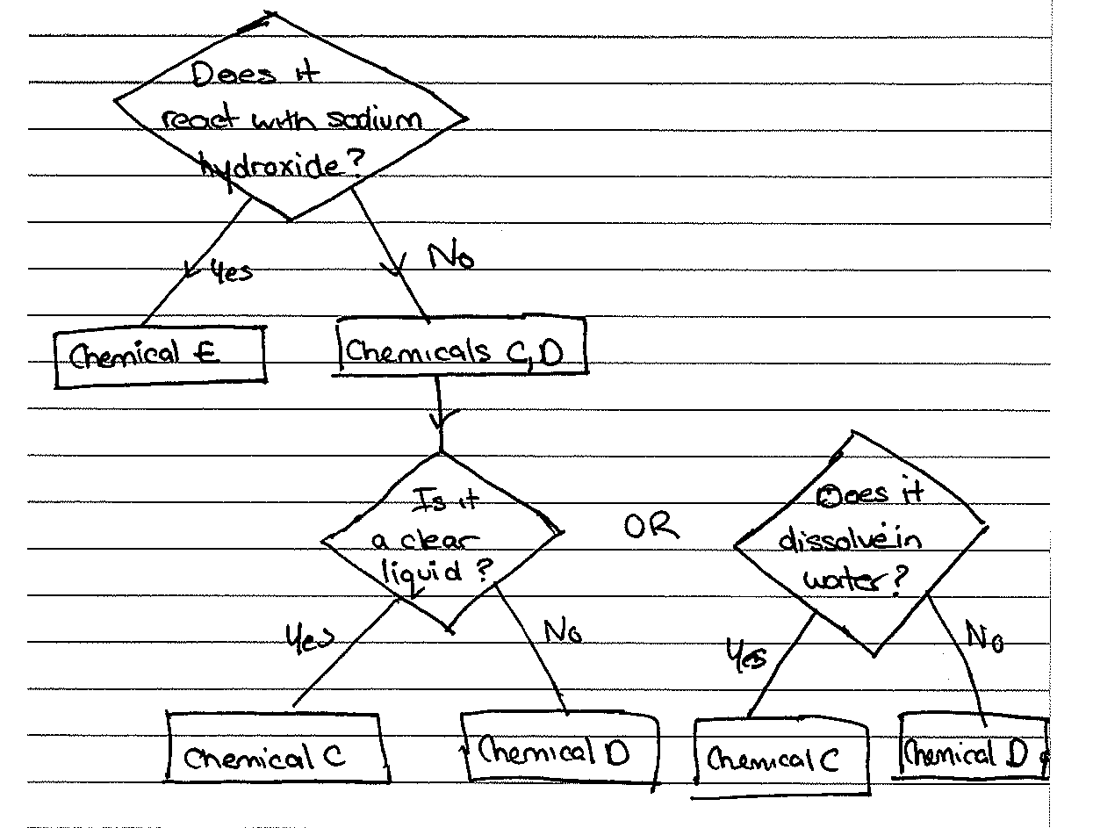

Question 30.



1. Fires
2. See diagram
3. Sulphur oxides are in much higher doses near power stations and could be toxic to lichens

Question 27:

* Set up the experiment with three identical pots, each containing three identical plants. Use the same type and amount of soil for each pot.
* Shine a lamp onto the three pots to provide good light
* Place a heater near the pots to maintain an approximate ambient temperature of 20o C
* Water each pot with 50 mL of tap water, every third day.
* Each day, measure and record the height of the plants. Continue to collect data for 14 days

Question 28:

1. I) expensive

ii) least active and hence it will corrode the least ie last longer

1. As aluminium is chemically quite active, it corrodes very quickly and hence is very difficult to extract from its ore.
2. i) Metals are very malleable which means they are easily shaped into sheets and can be used as aluminium foil for wrapping hot food. There are not many substances that are as cheap to purchase and easy to shape.

ii) most copper is recycled as it does not corrode easily due to its low chemical activity

iii) iron is very chemical active and hence corrodes often into rust.

iv) Copper is used for many everyday things such as saucepans and wires due to its high heat conductivity and ductile nature. It is difficult to find other substances that are abundant and have these qualities. Most likely cost will increase.

Question 29)

|  |  |
| --- | --- |
| Top | P |
| Middle | R |
| Bottom | Q |

ii) 66oC

iii) since the bar graph is 9 cm then P length will be 41% of 9 cm = 3.7 cm

Q length will be 24% of 9 cm = 2.15 cm

R length will be 35% of 9 cm = 3.15 cm

Question 29 continued:

b) physical

* doesn’t involve a colour change, chemical change, light or heat is not produced or gas produced or a precipitate produced

Question 26:

1. see diagram

cows

Grass

Human

chickens

Grass

1. i) Proton and neutron
2. Reactants – lithium-7 (consists of 3 protons and 4 neutrons) and a proton.

Products – 2 x helium-4 (consists of 2 protons and 2 neutrons)

1. e