Article source: https://www.abc.net.au/news/2017-02-02/clean-coal-explained/8235210
Accessed 7th March 2019

Clean coal explained: Why emissions reductions from coal remain a pipe dream
By Stephen Long
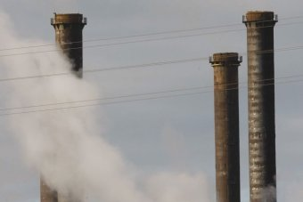
Posted 2 Feb 2017, 1:52pm
PHOTO: Federal Resources Minister Matt Canavan wants a new coal-fired power station built in Queensland, despite the state's insistence it would prefer greener solutions.(Reuters: Mick Tsikas, file photo)

"Clean coal" has been the holy grail of the fossil fuel industry for decades: the concept of creating commercially-viable ways of stopping the carbon emissions from coal-fired electricity plants which contribute to global warming.
Advocates use the phrase to describe two different technologies: carbon capture and storage; and highly efficient, lower emissions coal-fired power stations.
Carbon capture and storage is based on the principle of catching the carbon emissions, or CO2, from burning coal before they are released into the atmosphere.
It works by forcing the exhaust from a coal-fired power plant through a liquid solvent that absorbs the carbon dioxide, heating the solvent to liberate the gas, then compressing it and sending it away for storage underground.
Great in principle, but the technology faces big hurdles in practice.
One is the huge cost and logistical challenge of transporting all the captured carbon dioxide and burying it.
It would require a vast network of pipelines and storage sites.
As one doubter observed: "Collectively, America's coal-fired power plants generate 1.5 billion tons per year. Capturing that would mean filling 30 million barrels with liquid CO2 every single day — about one-and-a-half times the volume of crude oil the country consumes."

Australian government's coal power push
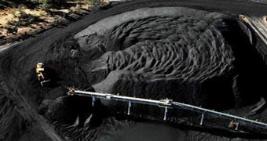
Treasurer Scott Morrison says the Clean Energy Finance Corporation could be used to fund new clean coal power stations.
The cost of building the required infrastructure would be enormous and the time periods involved may be too long to prevent the risk, identified by the consensus of expert scientists, of potentially catastrophic climate change.
The International Energy Agency (IEA) has found that the world would need to capture and store almost 4 billion tonnes per annum of CO2 in 2040 to keep global warming to 2 degrees Celsius above pre-industrial levels.
Far more would be needed to limit it to 1.5C, the target agreed to by 195 nations at the Paris climate conference in 2015.
Yet current carbon capture capacity for projects in operation or under construction sits at approximately 40 million tonnes per annum.
We also don't know if all gas would stay buried. While scientists are confident that there are geologically stable areas that could keep the carbon underground for very long periods, there is a risk of carbon seeping into the atmosphere.
To date, the technology is not commercially viable.

'Cleaner coal' sometimes mislabelled 'clean coal'
High efficiency, low-emission power stations, also known as ultracritical or supercritical coal-fired power plants, are sometimes also labelled as "clean coal".
The power stations operate by burning thermal coal at ultra-high temperatures that increase efficiency and reduce the level of carbon emitted.
The best of the new breed of plants can reduce emissions by up to 40 per cent compared to some older-style coal-fired power stations, according to the International Energy Agency.
But to call this "clean coal" is misleading. The new generation plants are less damaging to the environment, but they are not clean.
Even the best of the high-efficiency, low-emission plants emit far more carbon into the atmosphere than gas-fired power stations.
Coal, by nature, is not clean. Aside from releasing CO₂, which contributes to global warming, burning coal releases sooty particulates that can cause cancer and respiratory problems, sulphur and nitrogen, which contribute to acid rain, and other toxic chemicals.

High cost of coal power
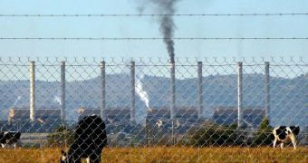
Energy experts and industry groups say building new coal power stations could drastically raise electricity costs.
Developing more efficient, less polluting coal-fired power stations may be a worthy goal and a part of the future energy mix but, alone, it won't allow Australia, or the world, to meet stated climate change goals.
The cost of retro-fitting Australia's ageing coal-fired power stations as high-efficiency, low-emission power stations would be enormous — and the cost may fall on the taxpayer.
Banks are wary of funding new coal-fired power plants at a time when pressure is mounting on lenders to shift away from fossil fuels.
The risk of a future carbon price being imposed, pushing up costs and undermining financial viability, would also weigh on the minds of lenders and investors.
At the same time, the costs of zero emissions technologies are continuing to fall.

Questions:

- What does the expression ‘carbon capture and storage’ mean?

- Explain how the process of carbon capture and storage works.

- Outline some arguments against the use of this kind of technology.

- Assess the accuracy of the term ‘clean coal’.

- Name some science fields/jobs that may be involved in this type of new environmentally friendly technology.

