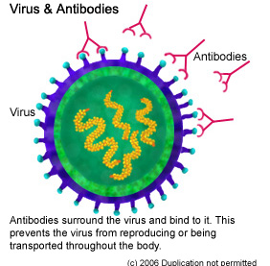
‘Battle Scars’ Worksheet

- What is disease?
- Complete table 1 of the different pathogens that cause infectious diseases AND paste into your book:

- The Body’s FIRST Line of Defence

- The two main parts to the body’s first line of defence are the skin and moist membranes. Name the five parts of the body that have moist membranes and identify their main function.

- How can pathogens gain entry into the body?

- What is the effect of washing your hands?

- The Body’s Second Line of Defence

- First let’s learn about our Blood. Where are blood cells produced in our body and which cells actually produce them?

- Complete table 2 and paste into your books:

- EXTENSION: What are platelets?

- What is the other name for the second line of defence and why is it called this?

- Create a flow chart that shows the steps that occur when a pathogen such as bacteria enters the body through a break in the skin. Include diagrams that show how a phagocyte engulfs the bacteria.

- The Body’s Third Line of Defence

- How does the body identify pathogens as different to its own cells?
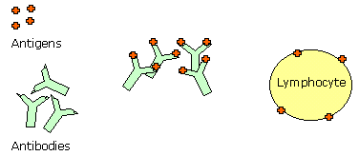
- The third line of defence is a highly specific response that is made up of millions of different lymphocytes. Each lymphocyte is designed to identify a specific pathogen. Where are these lymphocytes produced and where do they stay in the body?
Lymphocyte

NOTE: Continue to watch the remaining sections of the video to begin your understanding of the two different types of immune responses. I will provide much simpler notes for these.

Table 1

Infectious Diseases | Pathogen | Diseases caused
 | - Bacteria | 1)  2)  3)
 | - Fungus | 1)  2)
1)
2)
3)
4)
5)

1)
2)

1)
2)

Table 2

 | Red Blood Cells | White Blood Cells
How much is in the blood?
What do they do?
Where are they found?

