Model Natural Selection using Jellybeans!
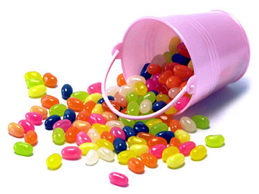
You will need:
- sheet of clean paper to put your jellybeans on
- packet of jellybeans
- plastic ice cream tub for the class
- calculator
Instructions:
1. Separate all of the jellybeans into the different colour and count the number of each different coloured jellybean. Record your results in the table below.
2. Calculate the percentage of each colour by dividing the number of the separate colours by the total number of jellybeans and multiplying by 100.
3. Wash your hands and the teacher will give you five jellybeans – do NOT eat yet!!!!!
4. Pick out only two of your favourites from these five (yes, you can eat them, or just put them aside).
5. Return your remaining three jellybeans to the container with the rest of the jellybeans.
6. Repeat this three times. Each student (predator) should have preyed on (eaten!) six jellybeans.
7. Count up the remaining beans, and calculate again the percentage of each of the colours

Colour | At the start |  | After 3 ‘generations’
 | Number | Percentage of total | Number | Percentage of total
TOTAL |  | 100 |  | 100

Discussion:
1. Were all jellybeans of all colours consumed equally?
a) How do you know?

b) Why did this happen?

2. Natural selection requires a ‘selection pressure’ to cause the characteristics of the species to change. What was the selection pressure in the jellybean model?

3. Natural selection results in a population that is better adapted from the environment. How is this demonstrated in the jellybean model?

4. Assuming that the environment remained constant, what might happen to the jellybean population over time?

5. Natural selection requires variation among the members of a population. How is this represented in the jellybeans?

