Worksheet) Measuring Abiotic Factors

The diagram below shows data collected by a group of students on a field trip.

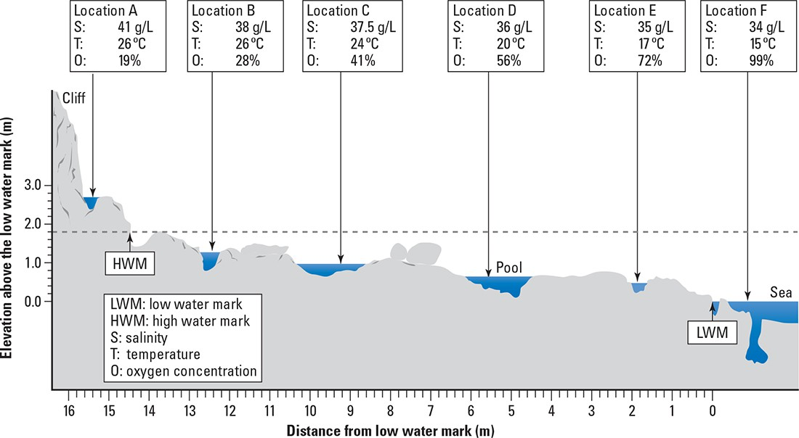

- Copy and complete the table below. Hint: Take the middle of each rock pool as the distance from the low water mark.

Location | Distance from low water mark (m) | Salinity (g/L) | Temperature (°C) | Oxygen concentration (% saturation)
A | 15.4 | 41 | 26 | 19
B
C
D
E
F | 0

- Construct the following graphs, either on graph paper or using Excel.
- A line graph showing distance from the low water mark on the x-axis and salinity on the y-axis.
- A line graph showing distance from the low water mark on the x-axis and temperature on the y-axis.
- A line graph showing temperature on the x-axis and oxygen concentration on the y-axis.

- Describe the trend shown in each graph.

___________________________________________________________________________

___________________________________________________________________________

___________________________________________________________________________

___________________________________________________________________________

___________________________________________________________________________

- The measurements were taken on a sunny spring day. Explain why the water in the pool that is furthest from the low tide mark contains water that is saltier and warmer than the pool closest to the low tide mark.
___________________________________________________________________________

___________________________________________________________________________

___________________________________________________________________________

___________________________________________________________________________

- Explain why many of the animals living in location F could not survive in location A.

___________________________________________________________________________

___________________________________________________________________________

___________________________________________________________________________

___________________________________________________________________________

