Food webs on a Rock Platform

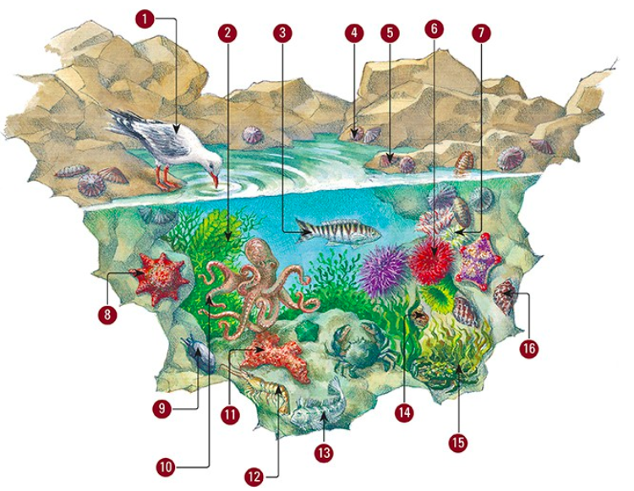
- Birds visit a rock pool to feed on fish, crabs, shrimp, sea urchins or shellfish
- Algae and sea plants use the sun’s energy to make food. Algae and seaweed are producers.
- Other larger fish, such as the zebra fish, may be found in rock pools. This fish feeds only on seaweed.
- Many snails, such as the conniwink, chiton and limpet, eat algae. They use their rough tongues to scrape algae off rocks.
- Many snails, such as the conniwink, chiton and limpet, eat algae. They use their rough tongues to scrape algae off rocks.
- Sea urchins hide during the day and move about at night feeding on algae. They have spikes to stop other animals eating them.
- Sea anemones have sticky tentacles that catch anything that floats by in the water. This includes fish, algae, microscopic animals, and plants called plankton.
- Sea stars eat anything they can find. This includes crabs, shellfish and algae. They push their stomach out through their mouth and digest food outside their body.
- The elephant snail has a shell that does not completely cover its body. It hides under ledges in rock pools and comes out at night to feed on algae.
- The octopus is an expert hunter. Octopuses eat fish, crabs and shrimp.
- Many animals, such as this sponge, filter the water for plankton.
- Rock pool shrimp are scavengers.
- The blenny fish is a common rock pool fish that eats other small animals, recently dead meat or algae.
- The green turban is a snail that feeds on larger seaweeds.
- Crabs feed on dead or decaying material in rock pools. Animals that feed on dead and decaying material are called scavengers. They eat anything they can find. The decorator crab covers itself in seaweed for camouflage.
- The dog whelk is a snail that eats other snails. It drills a hole through the snail’s shell with its rough tongue and sucks out the insides.

Questions
- Add the name of each organism labelled in the diagram to the appropriate column.

Producers | Herbivores | Carnivores | Omnivores

- Find an example of each of the following in the diagram.
- First-order consumer
- Second-order consumer
- Third-order consumer

- Refer to the information below to answer the questions that follow.
- Snails eat water plants and algae.
- Tadpoles eat algae.
- Small fish eat snails, algae and water plants.
- Large fish eat snails, small fish and tadpoles.
- Humans eat small fish and large fish.

- Construct a food web using this information. The producers should be at the bottom.
- Identify which organisms:
  - are producers
  - are first-order consumers
  - are second-order consumers only
  - are second and third-order consumers
  - are herbivores
  - are omnivores
  - compete for food
  - have more than one food source.
- Predict what would happen if overfishing led to a depletion in the number of large fish.

