2.2) The Menstrual Cycle

The menstruation cycle refers to the cycles in which a woman's uterus grows and sheds a lining (the endometrium) which could support the development of a fertilised egg. It typically occurs over 28 days

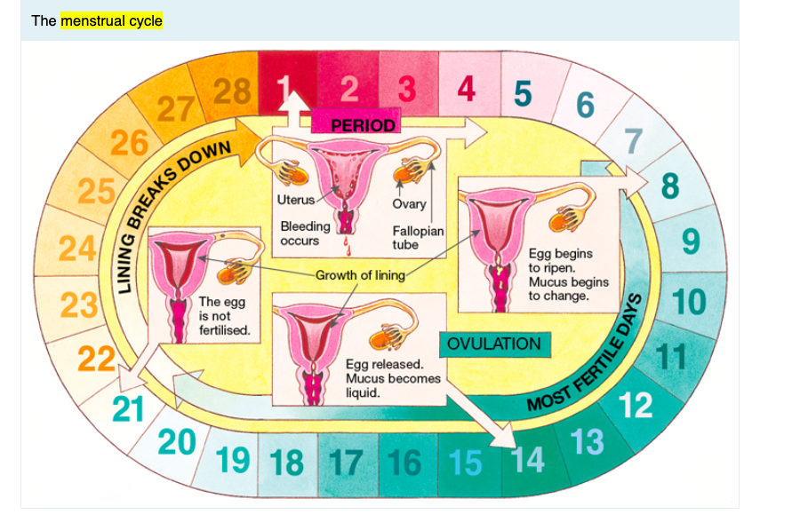

Day 1 is when a woman’s period starts. This is when the lining of the uterus is shed and the levels of the female hormones oestrogen and progesterone are at their lowest. After menstruation oestrogen levels rise and the lining of the uterus starts to thicken again so that it will be ready for an embryo if fertilisation occurs. In one of the ovaries an egg begins to ripen.

At ovulation a ripe egg is released from one of the ovaries. Ovulation occurs around day 14 of the menstrual cycle but this varies greatly between women. It is difficult to predict the time of ovulation simply by counting the days of the menstrual cycle. A more accurate estimate of the time of ovulation can be obtained by measuring and graphing body temperature. Temperature drops slightly before ovulation and then rises after ovulation has occurred. Hormone levels in blood, urine or saliva can also be used to indicate the time of ovulation. A hormone called luteinising hormone (LH) rises sharply just before ovulation.

What happens in the second half of the cycle depends on whether the egg becomes fertilised by a sperm cell. If the egg is not fertilised, it will not develop into an embryo and the endometrium (the lining of the uterus) will start to break down. The egg will eventually be passed out of the body. The hormone progesterone, another female sex hormone, gradually rises after ovulation.
Progesterone is involved in the menstrual cycle but it is also involved in pregnancy. Progesterone levels rise greatly during pregnancy. It prevents the uterus from contracting and pushing out the baby. Progesterone levels drop before childbirth and also just before menstruation. This allows the uterus to contract. Some women experience period pain. It is thought that in some cases this
pain is due to contractions of the uterus. The pain experienced in early labour is similar to this but much more intense.
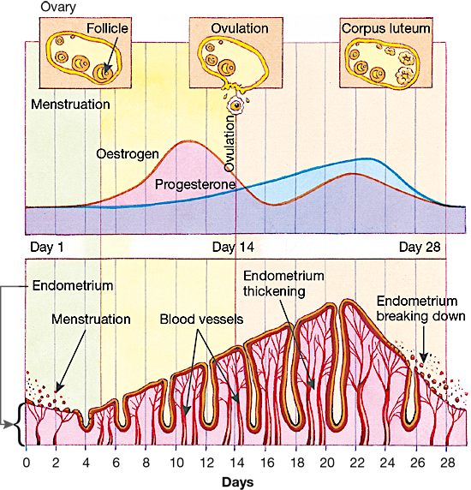

Week | Three things  - Where the egg is found  - Physical changes in the body  - Description of changes in oestrogen and progesterone
Week 1 | Period  i) the egg is in the lining of the uterus  ii) the lining of the uterus is shed. This is called the period  iii) oestrogen and progesterone levels are low
Week 2 | Ovulation  i) around the end of week 2 (day 14) the egg is released from the ovary and reaches the fallopian tube  ii) the lining of the uterus is building up again  iii) Oestrogen levels increase to the greatest level around day 10 and progesterone is starting to increase
Week 3 | i) egg travels along the fallopian tubes to the uterus to become embedded in the lining  ii) the lining of the uterus is thickest  iii) oestrogen drops to its lowest level as lining is not growing and progesterone is increasing till about day 20
Week 4 | i) if the egg is not fertilised then it remains unchanged in the lining of the uterus otherwise it develops into the embryo  ii) the lining of the uterus is breaking down  iii) oestrogen and progesterone levels decrease to their lowest levels

