Interpreting Graphs on the Ozone Layer (Jacaranda)

1. Ozone and altitude
The following graph shows the ozone level (measured as the pressure of ozone in millipascals) as a function of altitude. Answer the questions about this graph.

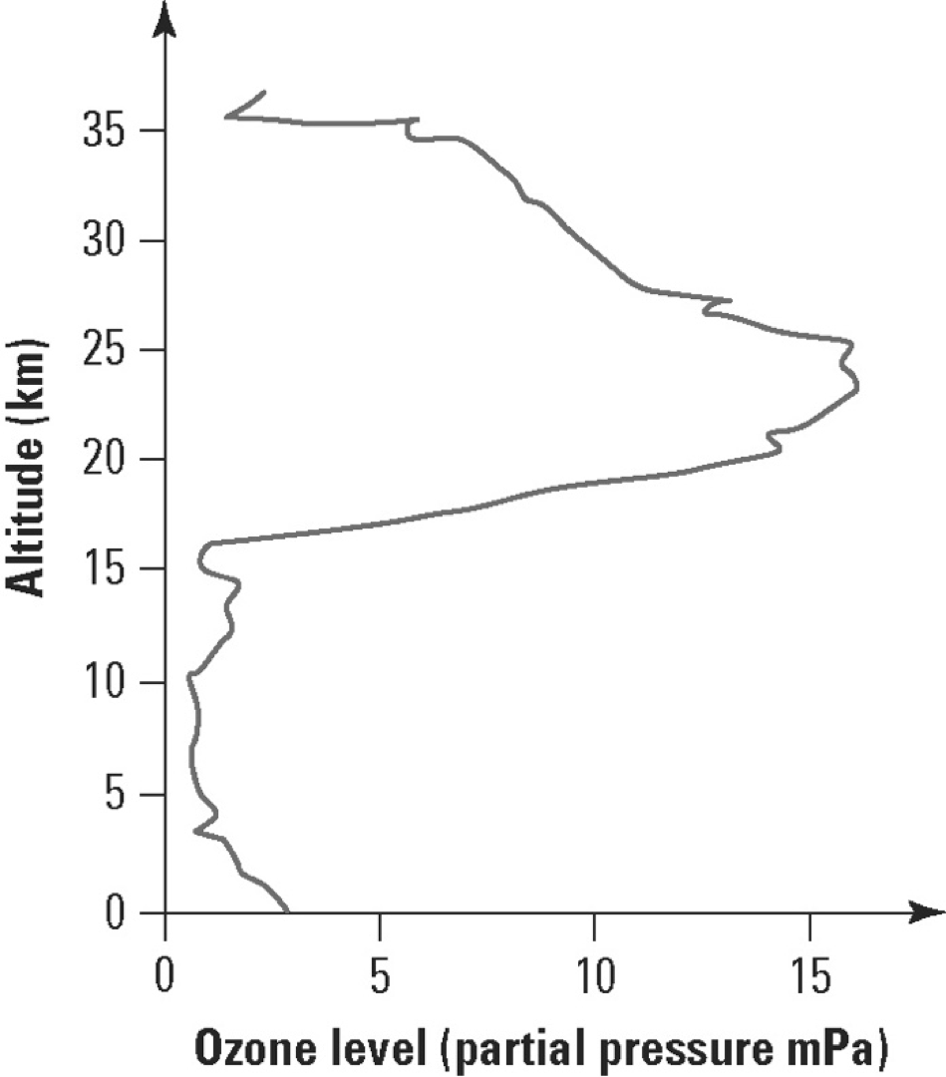

- What is the ozone level at sea level?........................................................................................
- At what altitude is the maximum ozone level? ..........................................................................
- In what atmospheric layer is the maximum ozone level located?
.............................................................................................................................................
- Calculate the ratio of the maximum ozone level in the stratosphere to the maximum ozone level in the troposphere.
.............................................................................................................................................

2. Ozone depletion
The following graphic shows changes in the area of the ozone hole in the stratosphere above Halley Bay, Antarctica, for the same four-month period over three different years. The ozone hole is a region of the stratosphere that has severely depleted levels of ozone. Answer the questions about this graph.

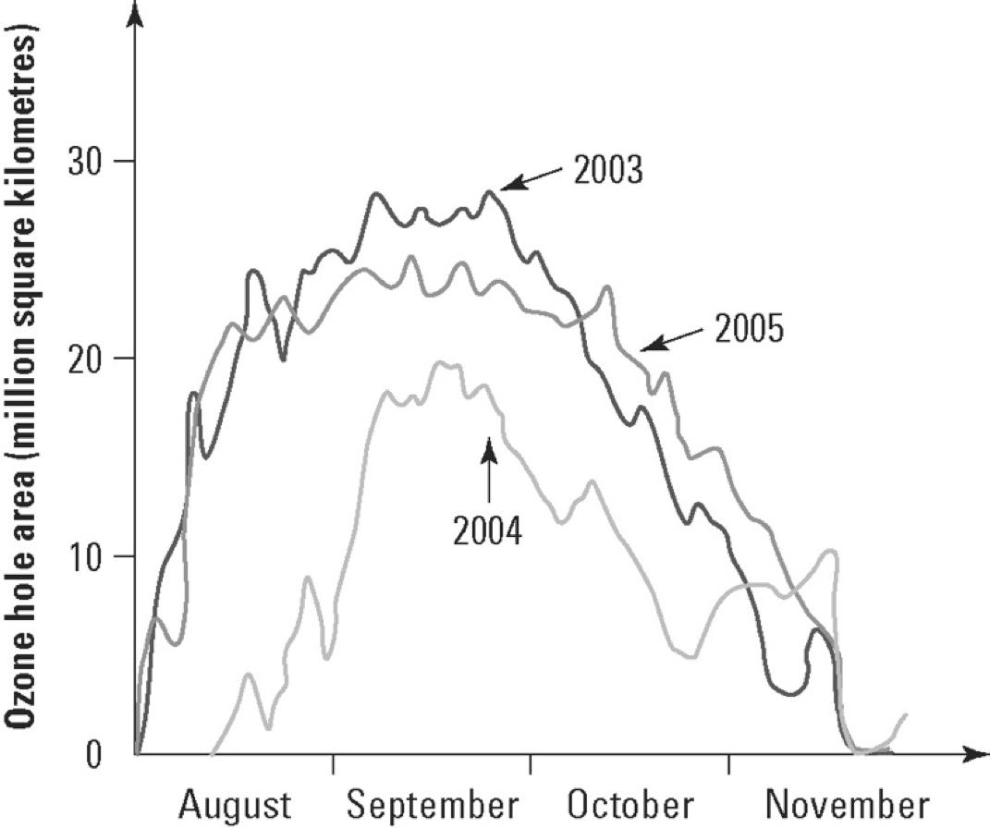

- In which season of the year do the largest ozone holes appear over Antarctica?
.............................................................................................................................................
.............................................................................................................................................

- Compare the area of the ozone holes over these three years.
.............................................................................................................................................
.............................................................................................................................................
.............................................................................................................................................

- Determine the size of the ozone hole at the end of September in 2004.
.............................................................................................................................................

- Studies in Chile showed a significant increase in skin cancer since ozone holes first started to appear in the mid1980’s. Explain
.............................................................................................................................................
.............................................................................................................................................
.............................................................................................................................................

