6.2) Speed and Velocity Problems

- Changing the speed from km/h to m/s.
Q; A motorbike is travelling at 60 km/h. What is their speed in metres per second (m/s)?
A: 60 ÷ 3.6 = 16.67 m/s
Therefore the motorbike’s speed is 16.67 m/s

- Change 30 km/h into m/s.
- Change 100 km/h into m/s.
- A dog is running along at 15 km/h. How fast is her speed in metres per second?
- A cheetah can reach speeds of 80 km/h. How fast is her speed in metres per second?

- Changing the velocity from m/s to km/h.

Q; A train is travelling at 40 m/s East. What is the velocity of this train in km/h?
A: 40 × 3.6 = 144 km/h
Therefore the train’s velocity is 144 km/h East

- Change 24.5 m/s into km/h.
- Change 288 m/s into km/h.
- A turtle is walking at 2 m/s North. What is the turtle’s veolcity in km/h?
- The space shuttle achieves a velocity of 5940 m/s upwards in a 2 seconds after its launch. What is its velocity in km/h?

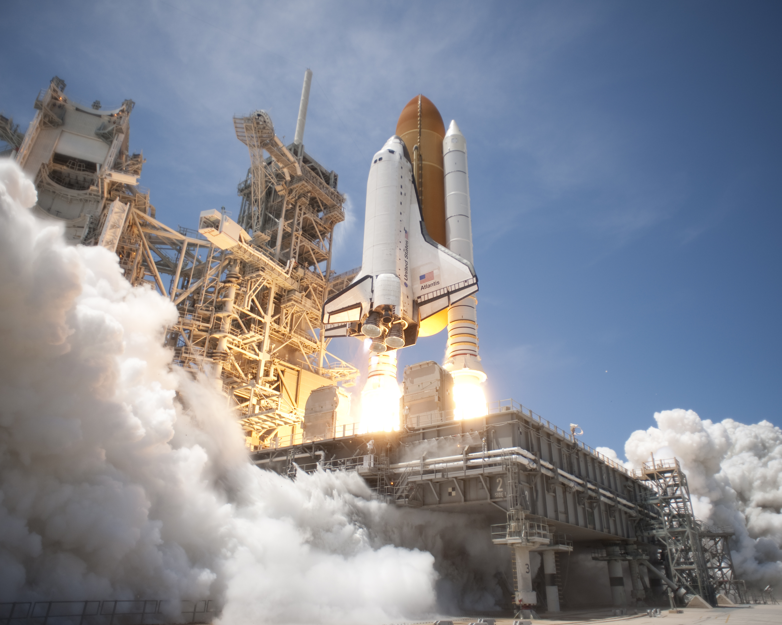

- Finding the speed of an object
Question: A bird flies 60 metres in 10 seconds. Calculate the speed of the bird?

Answer:
Speed = $\frac{distance}{time}$

= $\frac{d}{t}$

= $\frac{60}{10}$

= 6 m/s

- Calculate the speed of a hot air balloon if it travels a distance of 2000 m in 60 s?
- Calculate the speed of a child running to school from her house if her house is 3 km from the school and it takes her 0.5 hours?
- Calculate the speed of a car that takes 180 s to drive 500m?
- Calculate the speed of a surf ski that takes 1 hour to get to the next beach which is 8 km away?

- Finding the speed and velocity of an object

In a heat of a swimming trial, an athlete swims 100 m breaststroke event in 68 s. The event is completed in a pool that is 50 m long. She finishes the event at the same end of the pool from which she started. If she begins the event by swimming due North and takes 35 s to swim the first 50 m. Calculate her:

- Average speed for the whole swim
- Average velocity for the first 50 m.
- Average velocity for the whole swim.

- Finding the distance or displacement travelled by an object.

Question: A bicycle’s speed is 20 m/s. How far will it travel in 30 seconds?

Answer:
Distance = speed x time

d = vt

= 20 x 30

= 600 m

- An object travels at 4 m/s. How far will go in 55 s?
- A bus moves at 60 km/h. How many kilometres will it be from the bus stop if it has travelled for 1 hour?
- An aeroplane travels at velocity of 800 km/h West. What will be its displacement after 14 hours?
- A boat glides across the ocean at 30 km/h. How far will it be from the boat ramp if it has been travelling for 120 s? You will need to convert something!!

- Finding the time that it takes for an object.

Question: A bicycle’s speed is 20 m/s. Calculate how long it takes to travel 20 m?

Answer:
Time = $\frac{distance}{speed}$

= $\frac{d}{v}$

= $\frac{20}{20}$

= 1 s

- An object travels at 4 m/s. How long will it take the object to travel 100m?

- A butterfly flies from flower to flower at a speed of 1.5 m/s. How long will it take for this butterfly to travel around an average garden of 40 m?

- A boy rides a go-kart at a uniform speed of 42 km/h. How long does it take this boy to move 1500 m?

- Finding the speed using a distance/time graph.

An object moves along at 2 metres every second. The following table is drawn to represent this object’s motion. Create a graph of distance versus time and find the average speed of this object from its gradient.

Time (s) | 0 | 1 | 2 | 3 | 4 | 5 | 6 | 7 | 8 | 9 | 10
Distance (m) | 0 | 2 | 4 | 6 | 8 | 10 | 12 | 14 | 16 | 18 | 20

