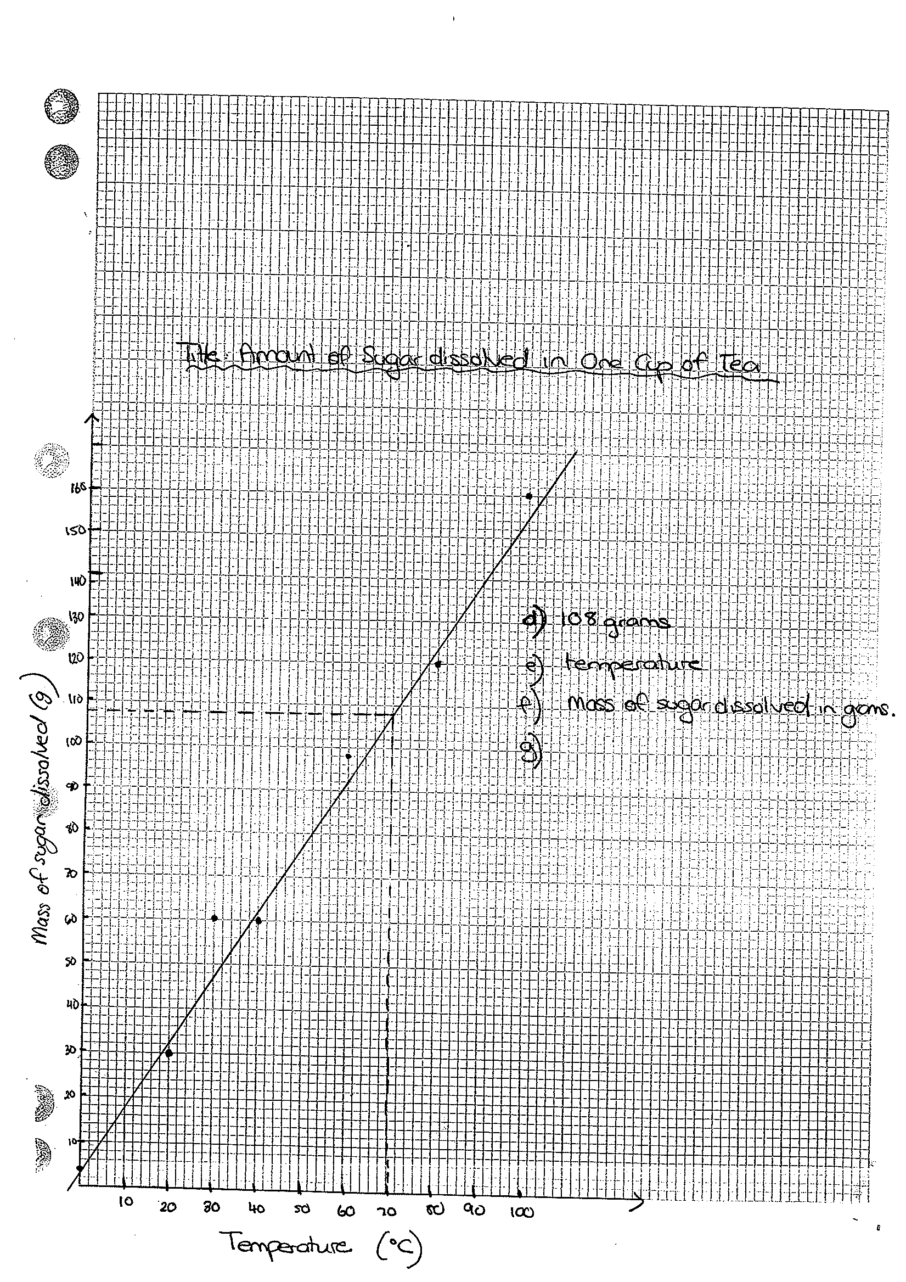
Graphing Exercises

d) 108 grams

e) temperature

f) Mass of dissolved sugar

g) Controlled variables would be the amount of tea in each cup, the type of tea used should be the same, the time that the sugar is allowed to dissolved in

h) An experiment is a fair test when it is VALID. An experiment is VALID when most variables are controlled AND if the method actually tests the aim. This is NOT a fair test as most variables have not been controlled even though the method does test the aim.

i) This experiment is not reliable as each temperature was only tested once and should be tested three times and the average determined.

