Experiment: Modelling solar and lunar eclipses

Aim: To model a solar eclipse

Equipment:
Torch, Globe and Tennis Ball attached to string
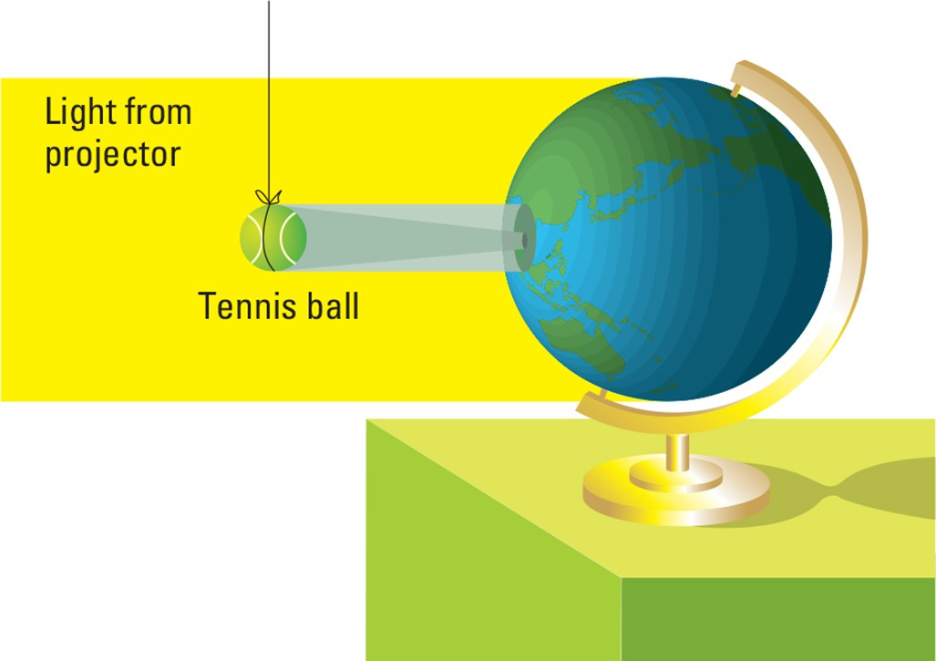

Method:
- Darken the room and aim a beam of light at the globe.
- To simulate a solar eclipse, suspend the tennis ball (moon) between the projector (sun) and the globe (Earth) as shown above. Ensure that you keep your own shadow off the globe.
- Rotate the globe a little (think carefully about which way to turn it) and note what happens to the shadow.
- To simulate a lunar eclipse, move the tennis ball to the opposite side of the globe from the projector. Suspend it so that it is partly in the shadow of the globe.

DISCUSSION
- Draw a diagram to show the initial positions of the Earth, moon and sun in your model of a solar eclipse.
- During which phase of the moon does a solar eclipse occur?
- When you rotate the globe, does the shadow move from east to west or from west to east?
- Draw a diagram showing the positions of the Earth, moon and sun in your lunar eclipse model.
- During which phase of the moon does a lunar eclipse occur?

