Year 8 Skills: Drawing and Interpreting Tables

- Always use a ruler
- Tables must have borders on each side
- Each column must have a heading and units in brackets.

Question A) Arrange the following information into a table and then answer the question provided.

A group of students carried out a survey in their school. They looked at various food items and recorded the amount of caffeine they contained. Here is a report of their findings:
In one can of Coles Cola, there was 35 mg of caffeine and in one can of Pepsi, there was 55 mg of caffeine. The amount of caffeine in one cup of instant and brewed coffee was 60 mg and 85 mg respectively. This was compared to one cup of weak and strong tea, which were 30 mg and 80 mg respectively.

Then we looked at chocolate. In most chocolate bars, there was 20 – 60 mg of chocolate in the whole bar. In a chocolate milk drink, there was only 7.5 mg of caffeine.

Some experts recommend that students consume no more than 200 mg of caffeine each day. How many cups of instant coffee would it be safe to drink?

Question B) Modern society relies heavily on metals. More than 60 metals are extracted from the Earth and used for all sorts of purposes. Each metal has its own properties such as density, strength, resistance to corrosion, hardness, conduction of heat and electricity and so on.

Even though new metals ores are being discovered, they are beginning to run out. There are two important ways that we can deal with this problem:
- Use recycled metals
- Find substitute materials

The table below gives some information about specific metals.

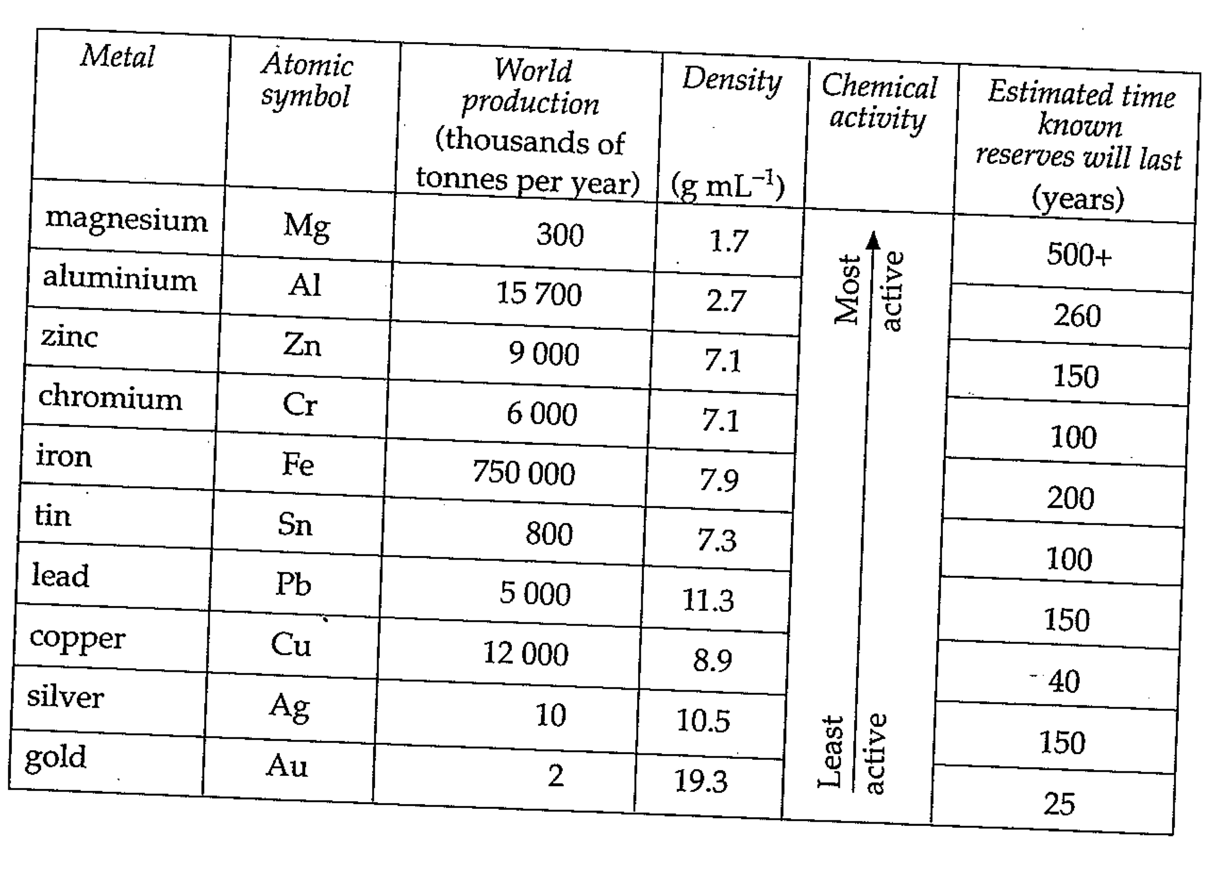

- Ignoring cost and using only the information provided:
- Give a disadvantage of making a car out of gold.
- Explain an advantage of making a car out of gold

- Aluminum is the most abundant metal in the Earth’s crust. Despite its abundance, aluminum is one of the more expensive to obtain. Using only the information provided, suggest a reason for this.

- Using the information given or your knowledge, to answer the following:
- Name a property of metals that is difficult to find a substitute material for. Explain your answer.
- Suggest one reason why most of the copper that we use is recycled
- Suggest one reason why less than half of the iron that we use is NOT recycled
- The world reserves of copper are predicted to run out in 40 years. Suggest one way that this may affect people.

